**Learning the Development Environment – The Next Step**

**Brian Baleva, Ben Na, Forum Suthar**

**ABSTRACT**

Continuing to expand upon C structures fundamentals, various utilizations of structures and pointers are defined and utilized to simulate communication between a satellite and mining vehicle. A clearer understanding of the system is provided by the use of different Unified Modeling Language (UML) diagrams.

**INTRODUCTION**

In this lab, the user is exposed to tools for simplifying and making useful programs of the C language. The user gains familiarity with the concept of creating structures in C, which is similar to creating objects in object oriented programming languages such as Java. The main structure the user is exposed to in this lab is the Task Control Block (TCB), which is used to efficiently run a function and also contain the data needed to run this function.

This data from the TCB is accessed through pointers, which provides the user a tool to manipulate and access data on a global scale of task execution. Pointers are an essential tool to C coding development, and the use of them were and will be widespread throughout this lab and future lab projects.

**DISCUSSION OF THE LAB**

In this lab, we are to implement a communication system between a space satellite and a mining station. Unlike the previous lab that was split up into tasks and applications, each of these tasks come together to simulate the communication system. These tasks are as summarized below in the following sections. Figure 1 below shows a high-level block diagram of the entire satellite management and control system. The functionality of all these blocks are discussed in detail.

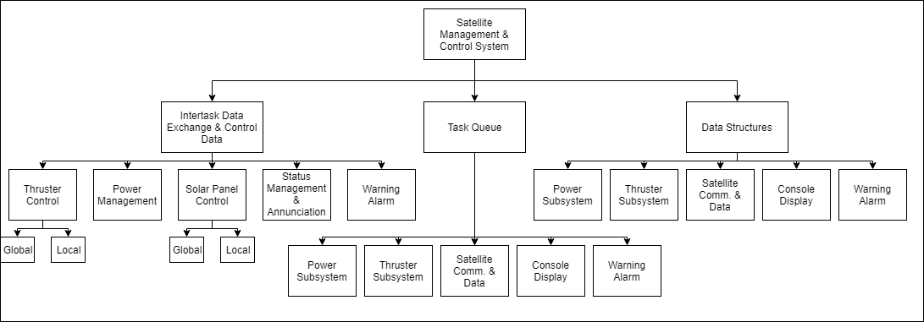

**Figure 1. High level block diagram/functional decomposition of system**

**Design Specification**

**Power Management and Control**

This module needs to keep track of key fields pertaining to the battery system. Fields that need to be tracked include power consumption levels, and overall battery level. The system comes with a simulated solar panel, so this function also must be able to change the operational state of this solar panel based off the needs of the battery.

**Thruster Management and Control**

Based off of a command from the satellite, this module must translate the command into three main fields: the direction, magnitude, and duration of the thruster command. By doing this, a method of showing fuel consumption must also be modeled.

**Communications**

This method sets up communication of key parameters to the mining vehicle system, such as transmit, annunciation, and warning systems. It must also come up with a way of generating a thruster command to send out to the satellite.

**Status and Annunciation Displays**

Two types of displays must be generated as a result of the communication, the first one being the status display. This must display parameters such as the state of the solar panel, battery level, power consumption and generation, and the current fuel level. For the annunciation display, indicators such as determining when the fuel and battery levels are at a “low” state must be defined, and shown on this display. The user must output this information onto a console display, but these displays can be shown on separate displays.

**Warning and Alarm**

A method of showing when fuel and battery levels are at a low state must be presented, separate from that on the annunciation display. A visual representation of these warnings must be shown alongside the ongoing status and annunciation displays.

Figure 2 below shows a UML-formatted Use Cases diagram that models this design specification and the communication between the satellite and mining vehicle in the system.

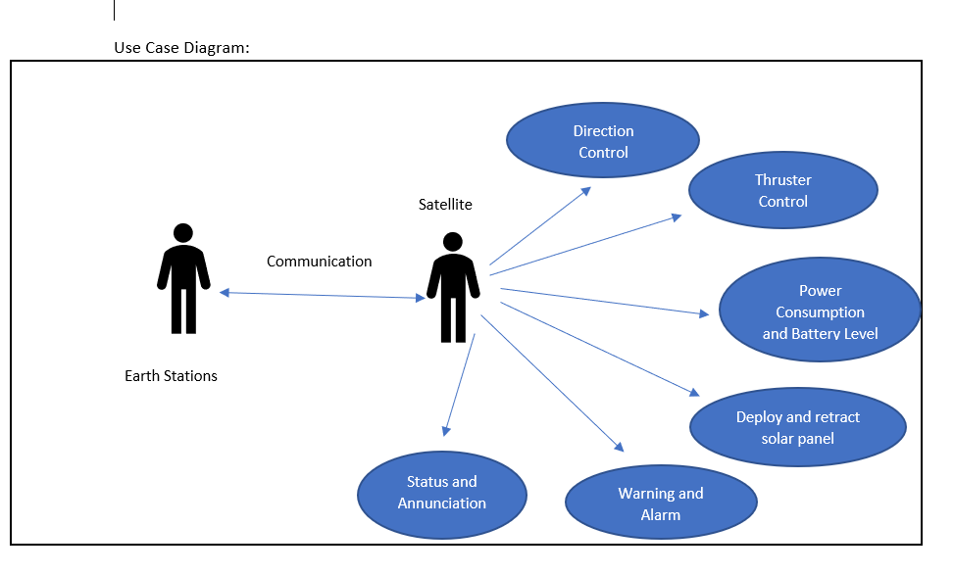

**Figure 2. Use Cases diagram representing communication systems**

**Software Implementation**

The following UML diagrams in this section represent the satellite communication system simulated during this project. Each diagram gets more specific into one particular function in this sequence. Figure 3 below shows a broad Functional Decomposition of the entire system, which forms the foundation of the different task functions. Figure 4 below it shows the interdependency between methods in the system, and also gives more details into the inputs and outputs of these different tasks. Note that for in-depth analysis of the software implementation, each of the tasks have pseudo code for the algorithms located in the Appendices section.

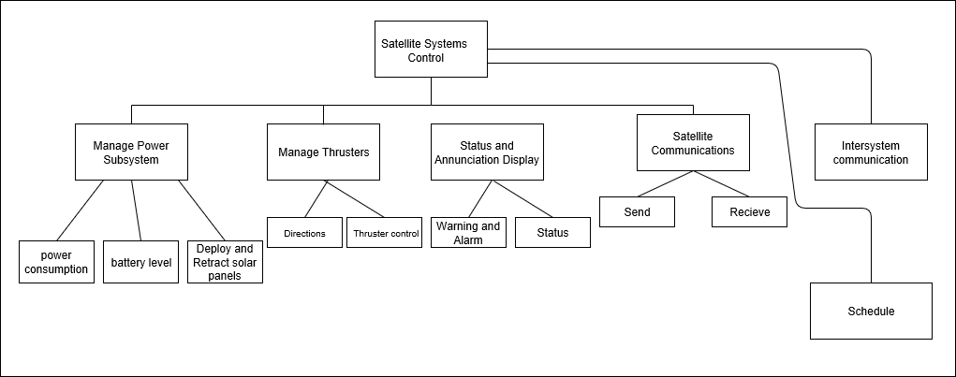

**Figure 3. Functional Diagram from the top-level Satellite System**

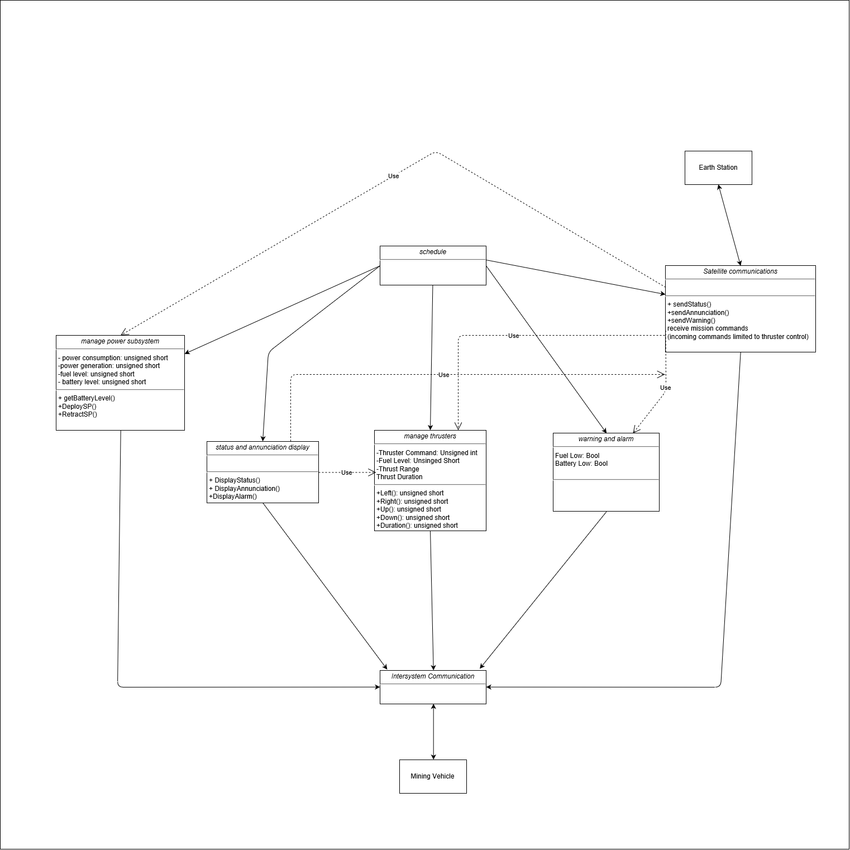

**Figure 4. Task/Class Diagram of individual blocks of communication system**

**Power Management and Control**

This function’s logic can be seen in the dynamic activity diagram shown in Figure 5 below. The logic is dictated by input parameters of solar panel state, and the current battery level. Based on these values, output values power consumption, power generation, and solar panel state are changed by the end of execution of the task.

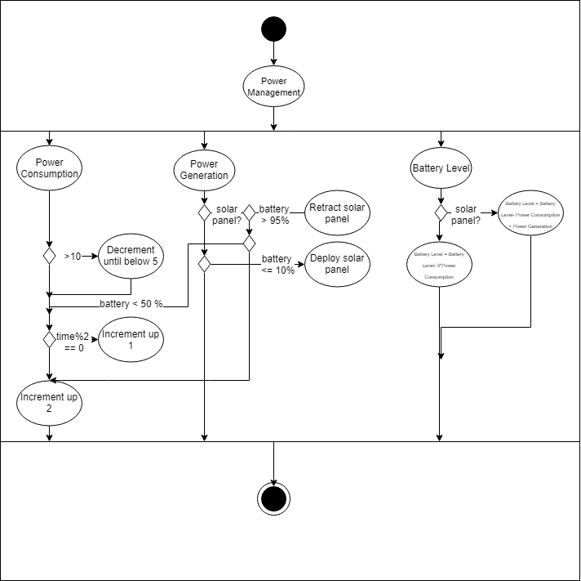

**Figure 5. Activity Diagram of Power Management Subsystem**

**Thruster Management and Control**

This method is responsible for taking in a command from the satellite communication system and breaking down the command based off of direction, magnitude, and duration. As seen in Figure 6 below, the direction of the thruster can go in all 4 cardinal directions, but magnitude and duration values must be assigned to all commands regardless of direction.

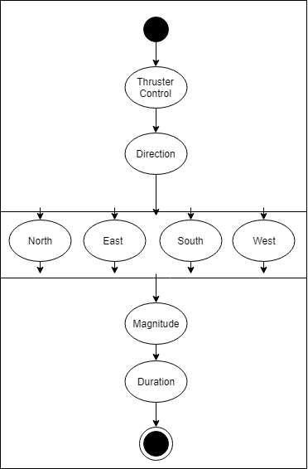

**Figure 6. Thruster Subsystem Activity Diagram**

**Communications**

The communication system takes the command generated by the thruster subsystem and breaks it into the three components of direction, magnitude and duration. Based off the magnitude of these values, the thruster command is simulated and implemented. Figure 7 below shows the all the possible combinations of commands for this system.

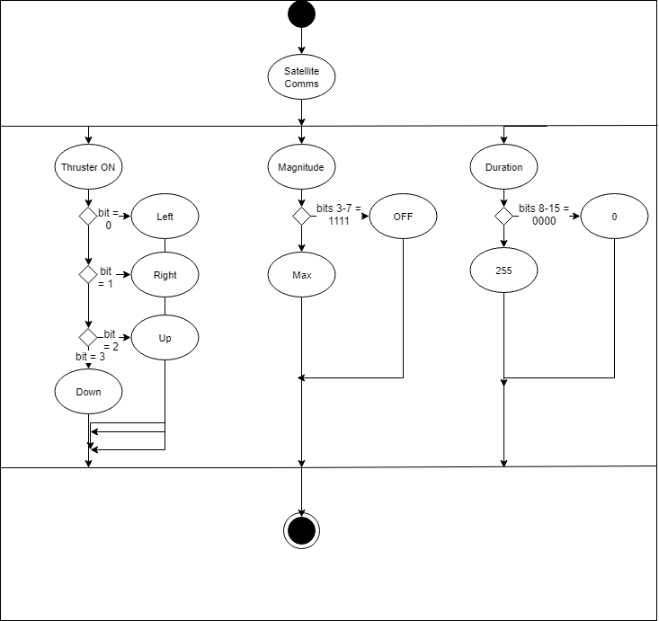

**Figure 7. Satellite Communication Activity Diagram**

**Status and Annunciation Displays**

The console display of the system is modeled by Figure 8 below, as the entire list of parameters displayed is shown. But, this display branches in two different directions, and it is up to the user to specify how this information will be shown. A breakdown of what information needs to be provided in each, for summary, is provided below:

Satellite Status:

* Solar Panel State
* Battery Level
* Fuel Level
* Power Consumption
* Power Generation

Annunciation Display:

* Fuel Low
* Battery Low

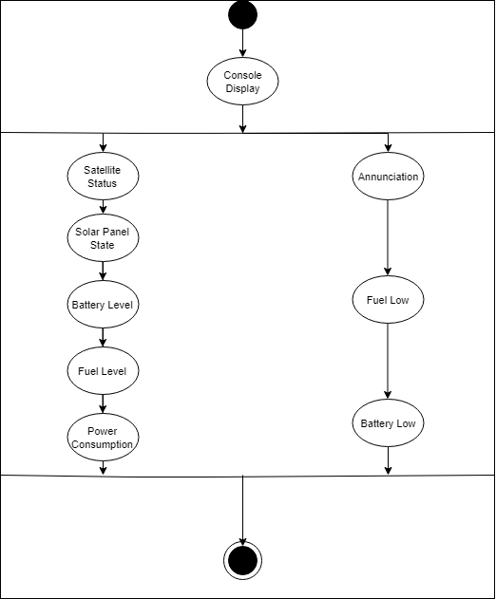

**Figure 8. Top level activity diagram of console display**

**Warning and Alarms**

Based off the current fuel level and battery levels, logic must be implemented to visually convey this information. The software is based off critical amounts specified in the requirements, and in this case, the critical values are below 50 and 10. The activity diagram in Figure 9 shows exactly how the display changes as a result of these conditions,

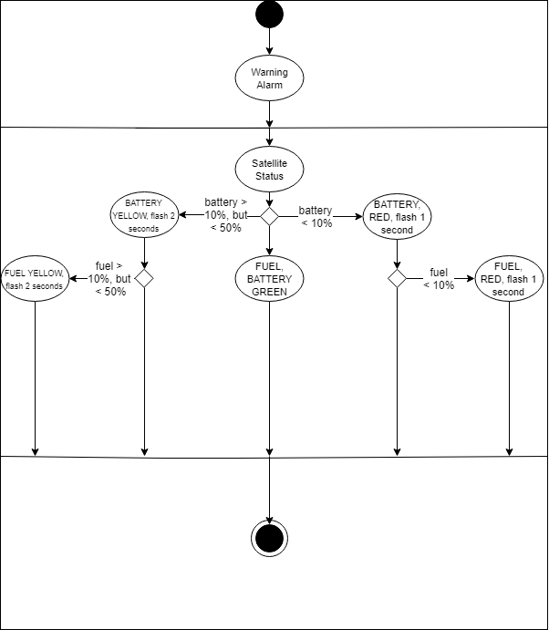

**Figure 9. Activity Diagram of Warnings and Alarms System**

**Tasks and Task Control Blocks**

The design of this system utilized a Task Control Block (TCB) structure that is a given structure that provides pointers to both a function that runs a task, and also the data needed to run the task. With this structure, the user can pass in data needed for the function, but also update that information globally after executing the program.

The TCB structure definition is provided in the Appendices section below. For each TCB, as mentioned previously, it provides a pointer to a function which is then executed. Function prototypes for each of the five tasks tasks are also provided and labeled as “Function Prototypes” in the Appendices Section.

**Task Data Structs**

As mentioned in the previous section, one pointer of each TCB is reserved to point to the data needed to run the function. Since each function uses and updates multiple values throughout the system, this pointer needs to point to a structure that contains data instead of just one global variable. The user accomplishes this by creating data structs for each function, which contains pointers to all global data needed for each function. As seen in the source code in the Appendices section, the following variables are declared globally:

* Thruster Command
* Battery Level
* Fuel Level
* Power Consumption
* Power Generation
* Solar Panel State
* Fuel Low
* Battery Low

For each data struct, if the task function requires one of these variables, it will create a pointer that can be accessed by the function. These task data structs are defined in the Appendices section under the “Task Data Structs” section. By creating instances of these data structs, the user can create individual pointers to reference each individual value.

**TCB Queue and Task Scheduler**

By creating TCB’s for the five required tasks, a method for running and dynamically updating values for each task can be achieved. In order for the system to continually update, however, the individual TCB’s need to be placed into a larger TCB system that can be indexed and run continuously. The user accomplishes this by creating a queue of TCB’s, which will continually be executed, task after task. This method can be inadequate, however, because the console and warning displays need some time to reflect on changes in data, so execution of other data changing tasks must be halted.

This scheduler will make sure that tasks that change data (Power Management, Thruster Subsystem, Satellite Communication), only run once every major cycle defined as 5 seconds. The console and warning display tasks continually execute during this time, enabling these displays to reflect the data correctly for the rest of the 5 second cycle. This queue and scheduler interface can be seen in Figure 10 below.

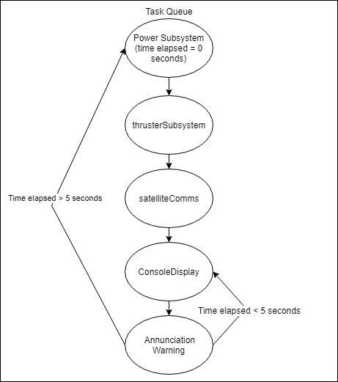

**Figure 10: Task Queue and Scheduler State Diagram**

**PRESENTATION, DISCUSSION, AND ANALYSIS OF RESULTS**

Visual results of this lab are present on two components of the system: the annunciation TFT display, and the console display from the Serial Monitor of the ATMega2560. Refer to the Pseudo Code or Source Code section for the specific code for implementing these displays.

**Annunciation Display**

The Warning Alarm task takes in the current fuel and battery levels, and prints it in various colors for a specified duration based off these levels. As mentioned above, the logic for the color scheme and blinking durations can be found in the source code below, but these pictures serve to illustrate the 16 different combinations that can be shown on the display.

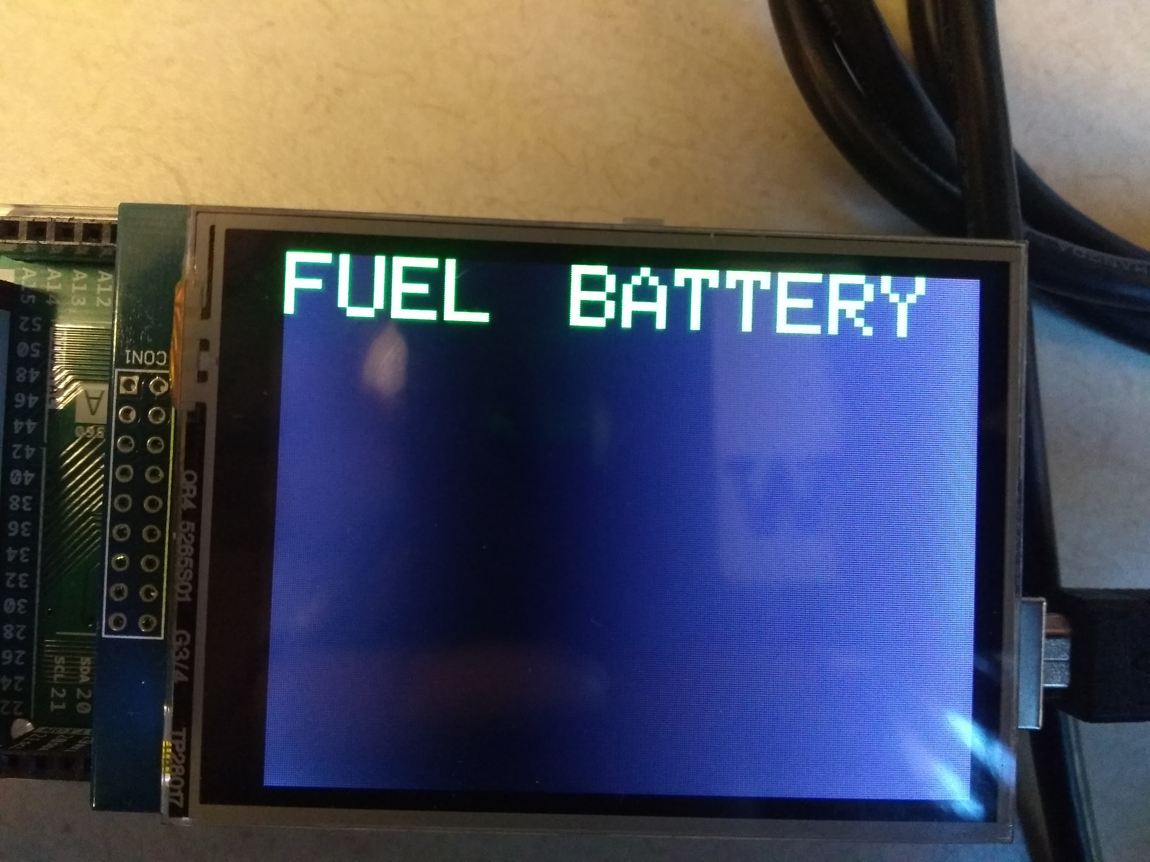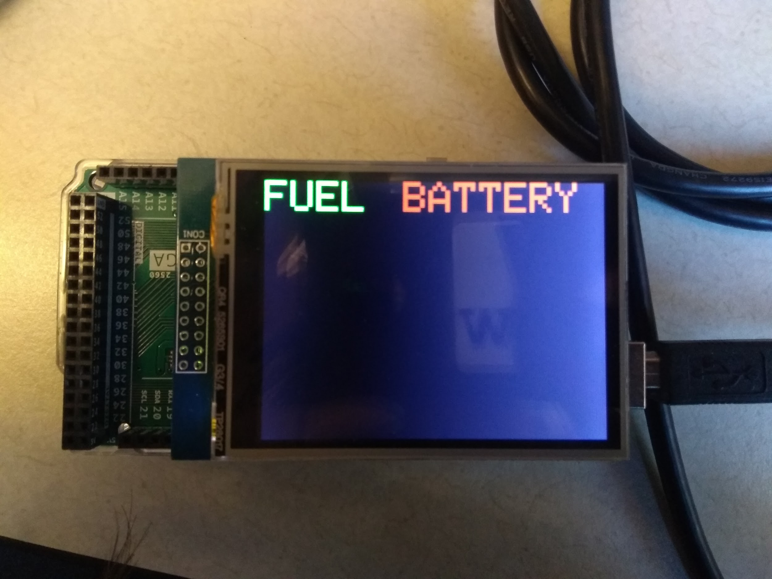

**Case1. Fuel and Battery > 50 Case2. Fuel > 50 Battery <50**

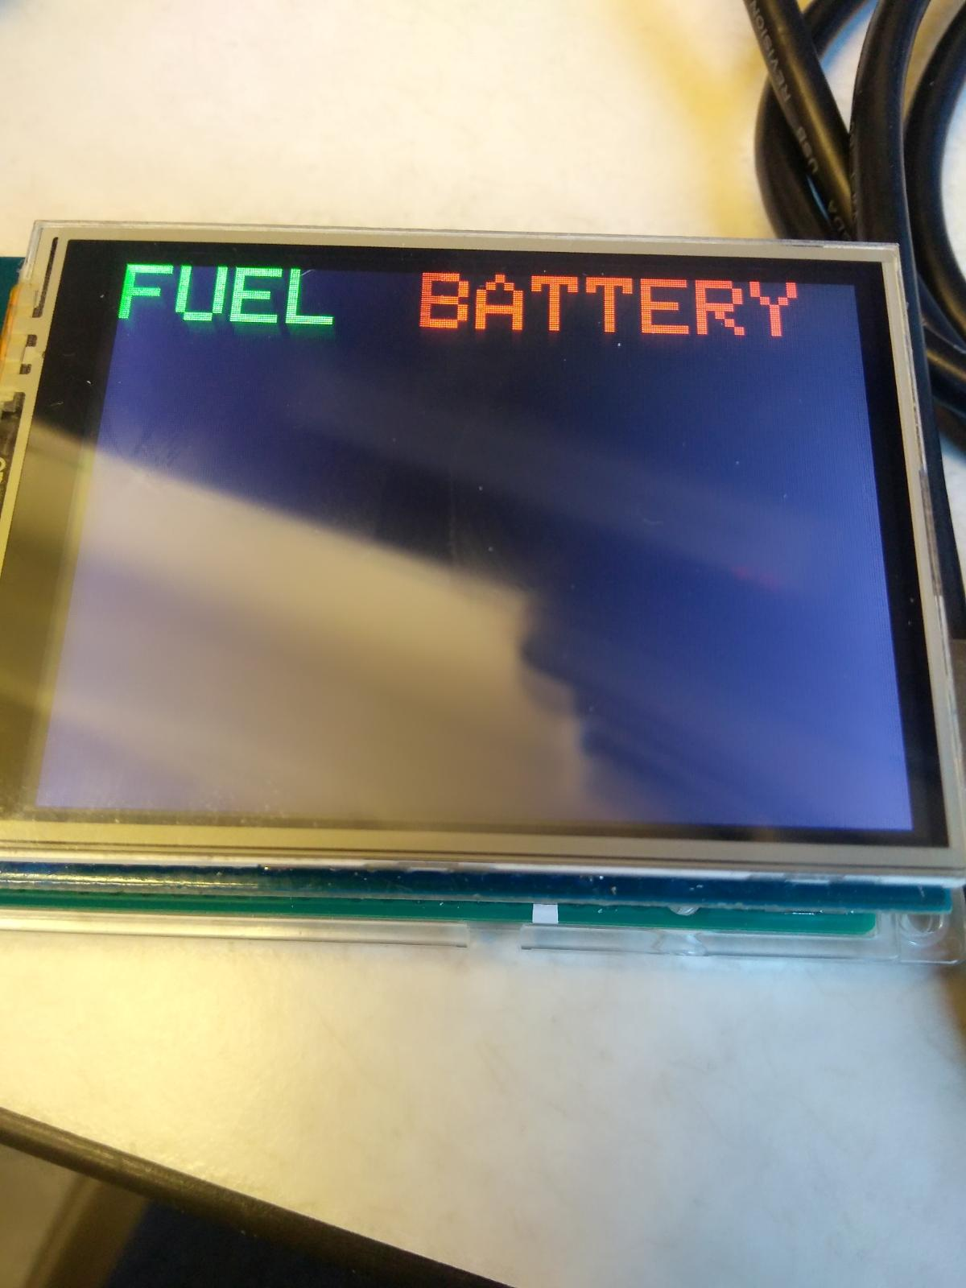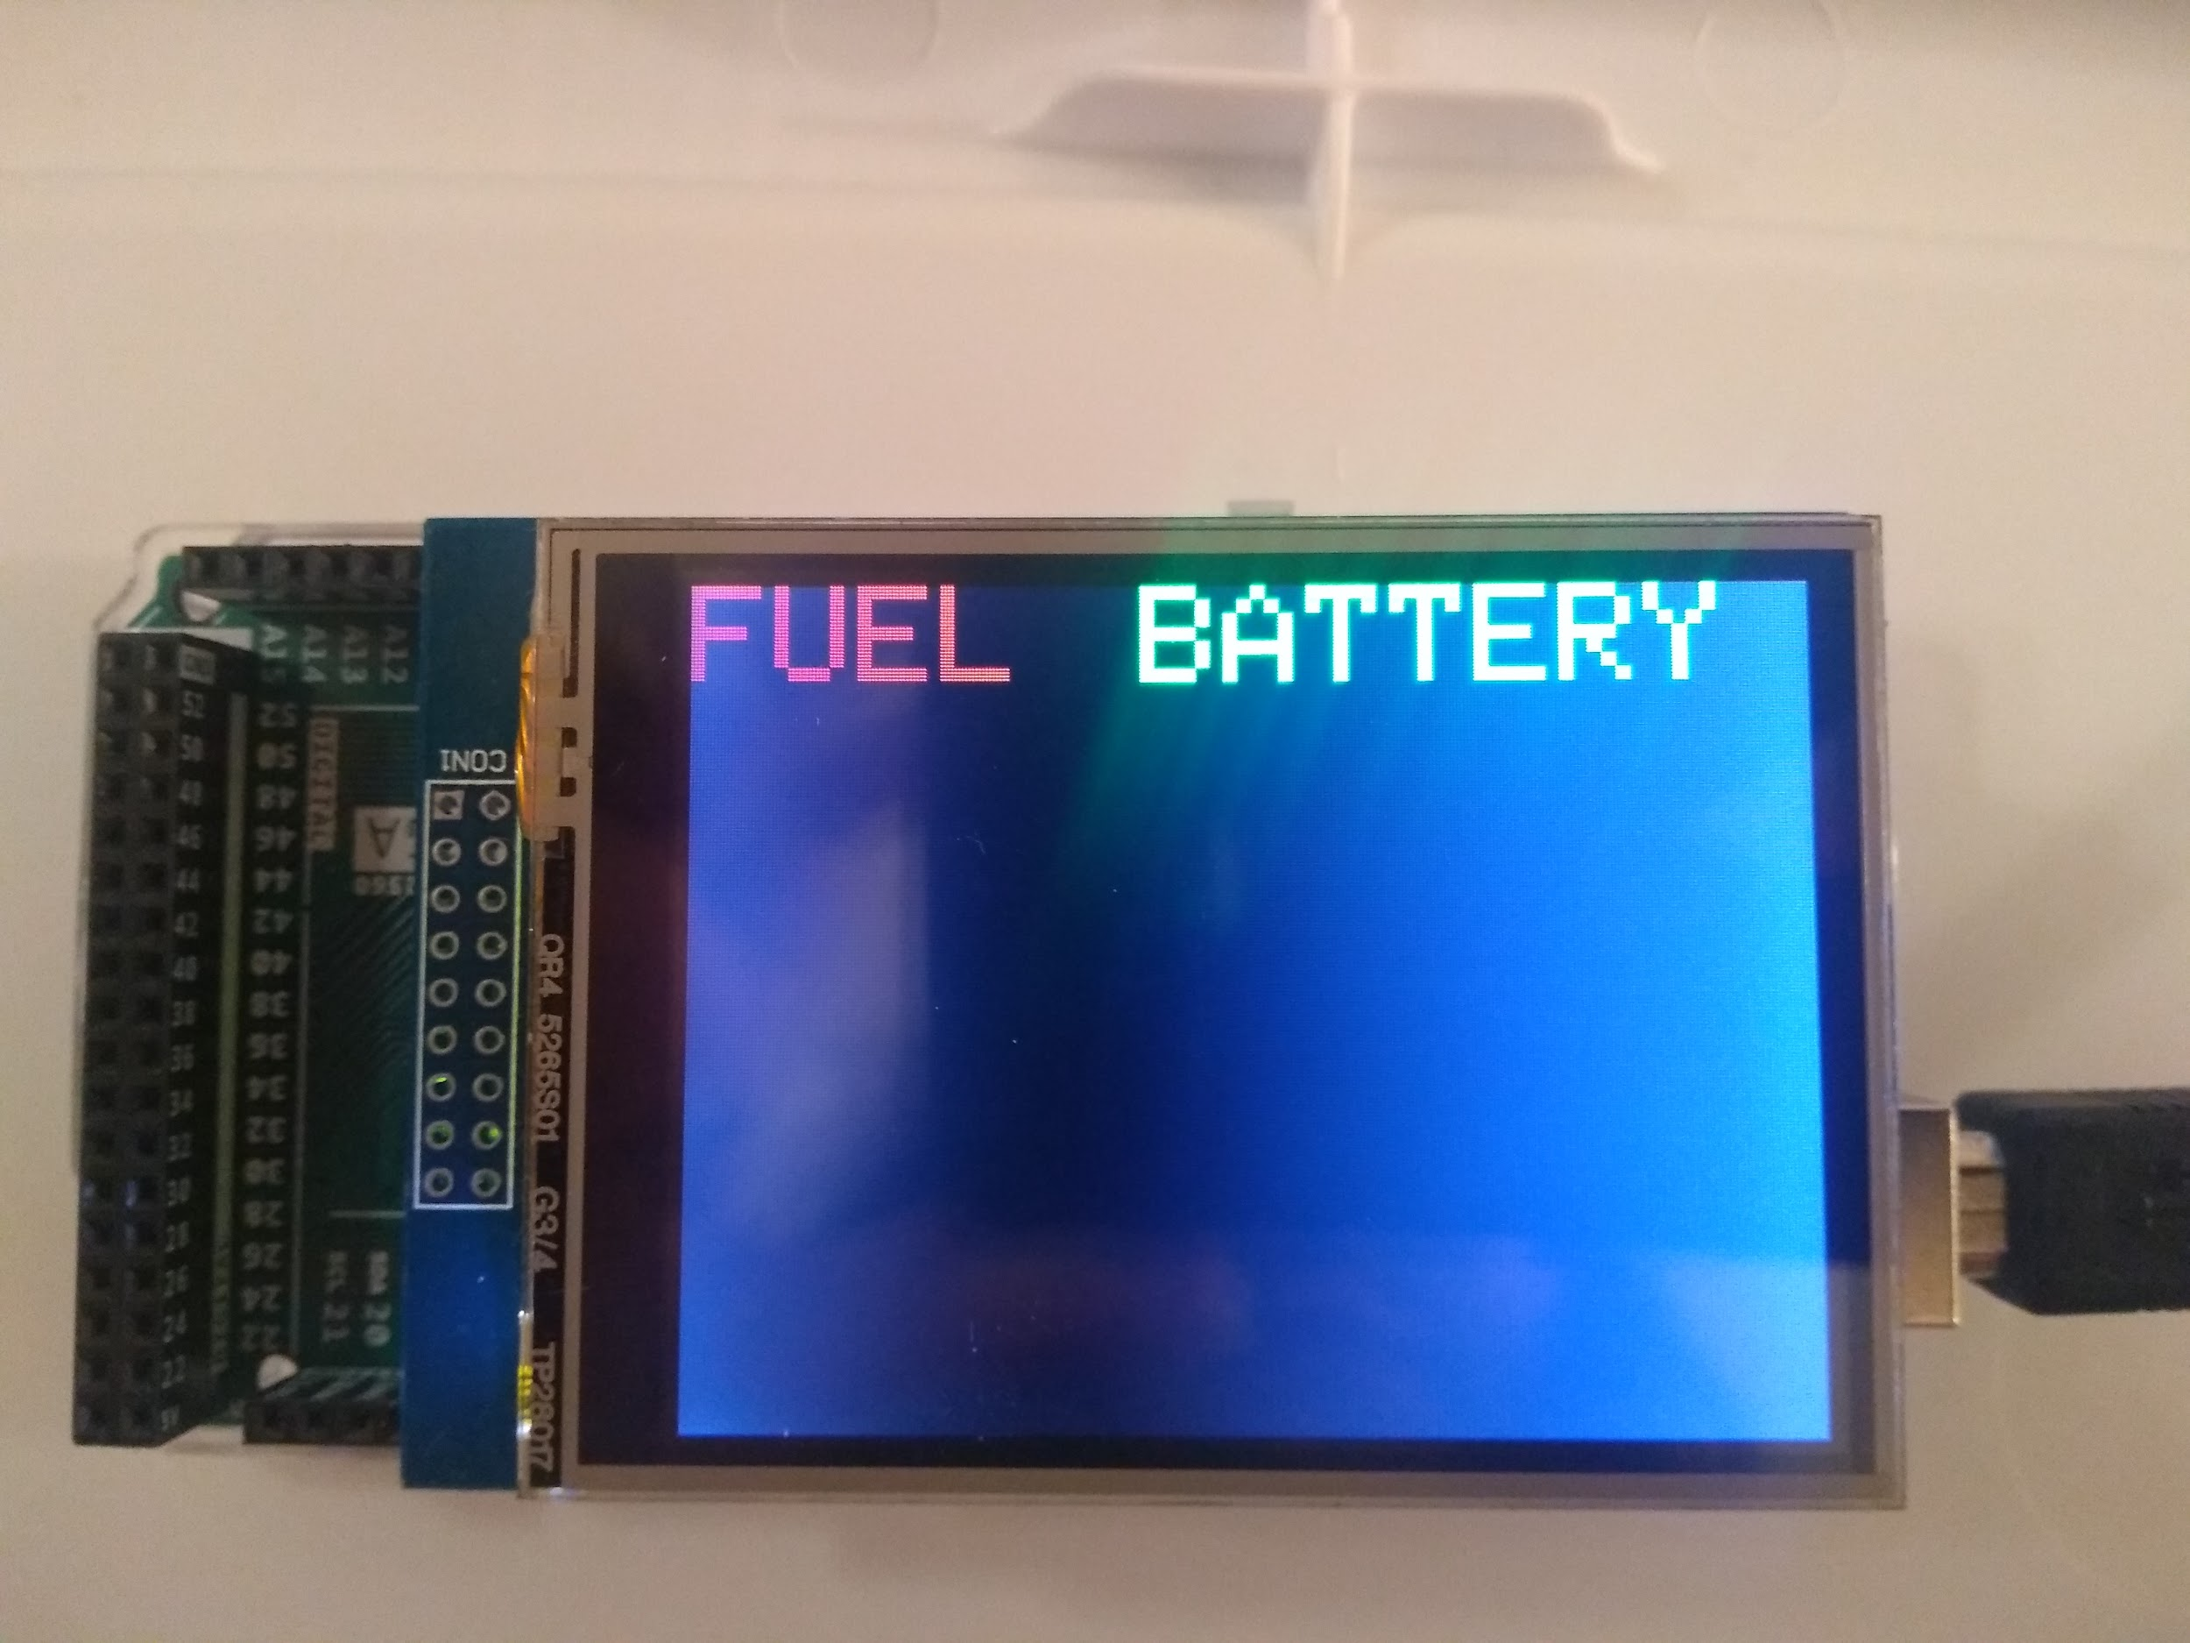

**Case 3. Fuel > 50 Battery <10 Case 4: Fuel < 50 Battery >50**

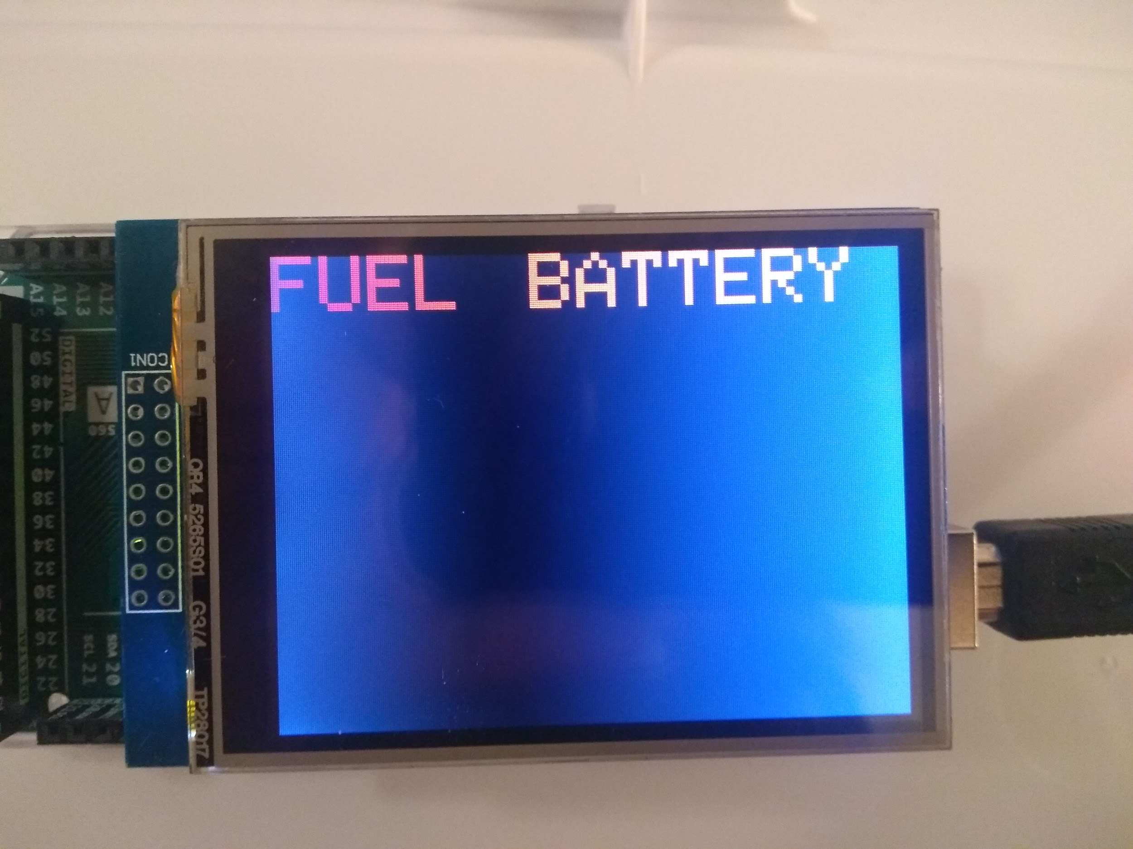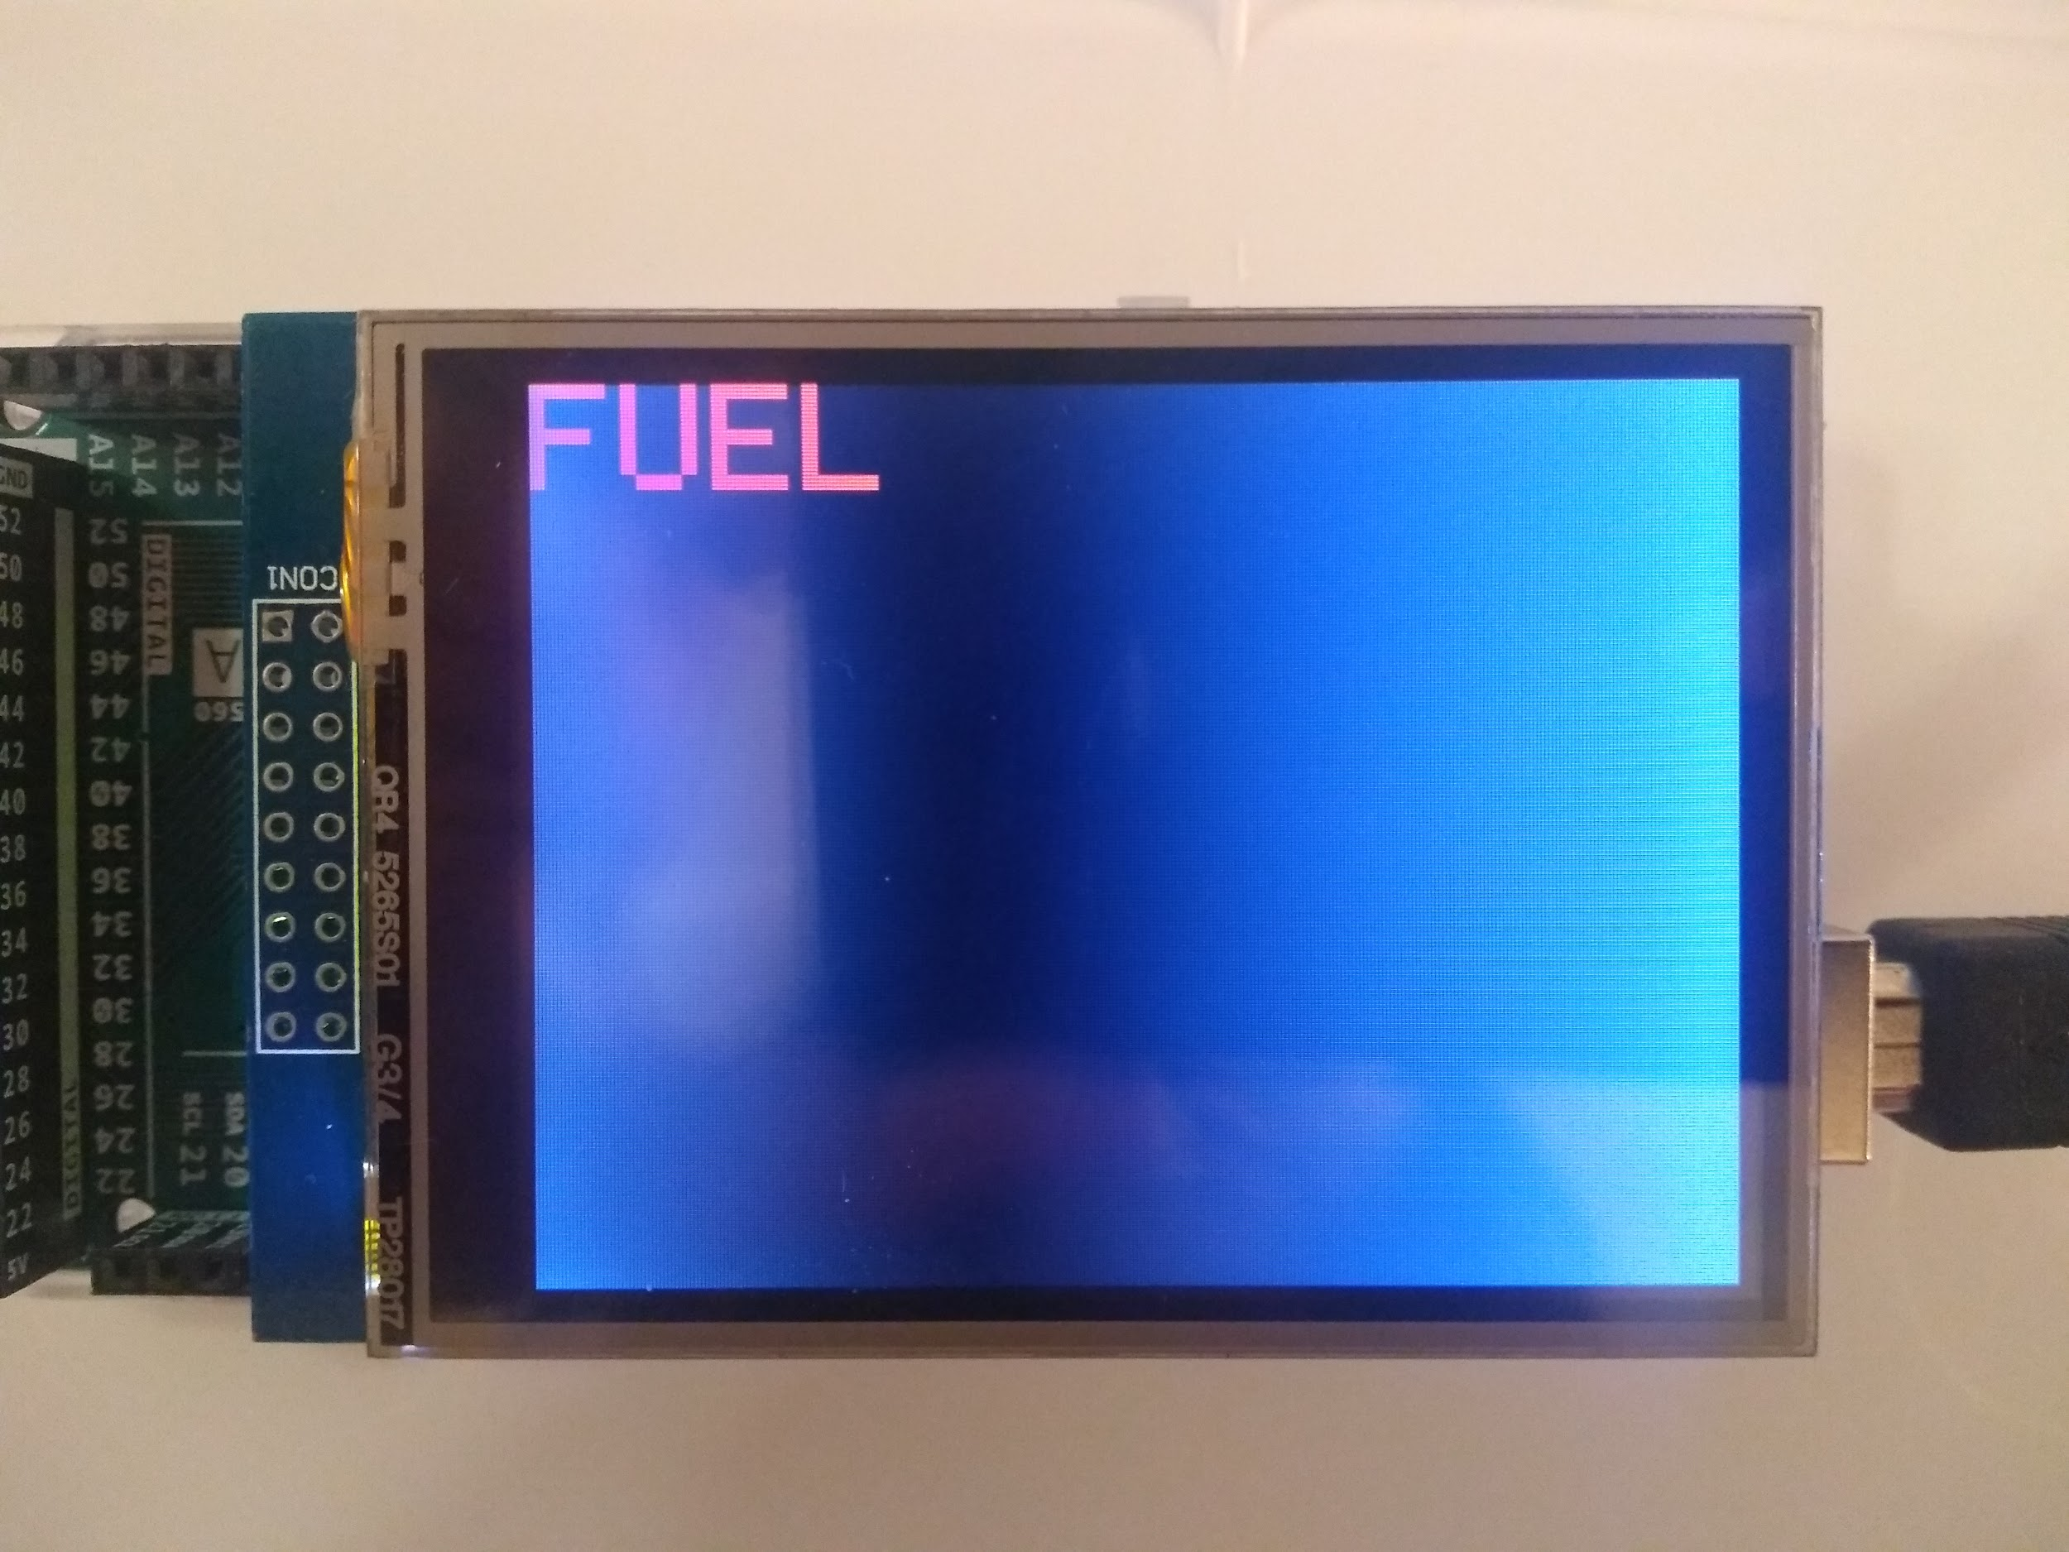

**Case 5. Fuel <10 Battery <50 Case 6. Fuel <10 Battery Flashing**

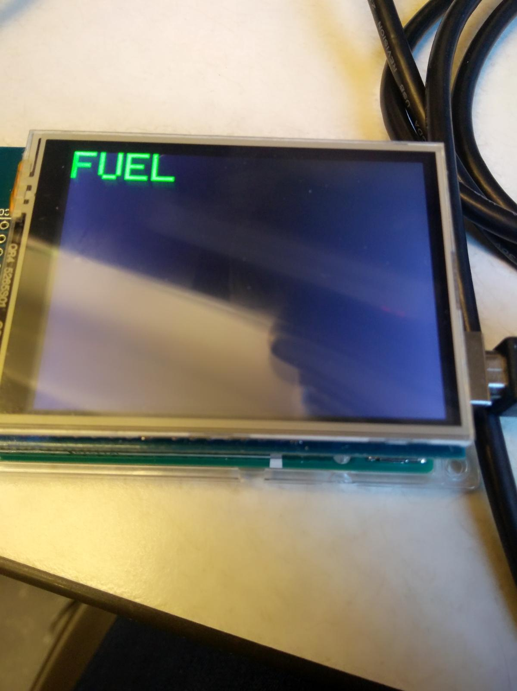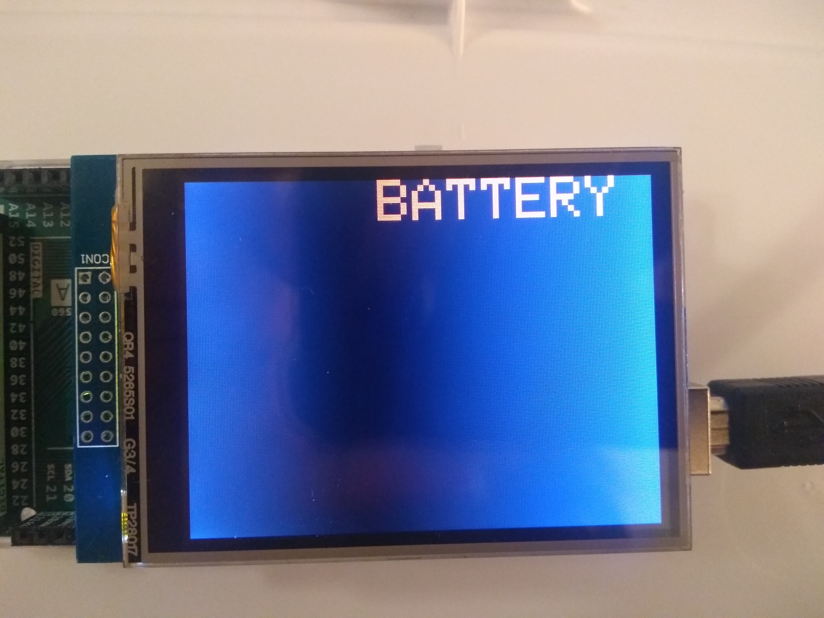

**Case 7. Fuel >50 Battery Flashing Case 8. Fuel Flashing Battery <50**

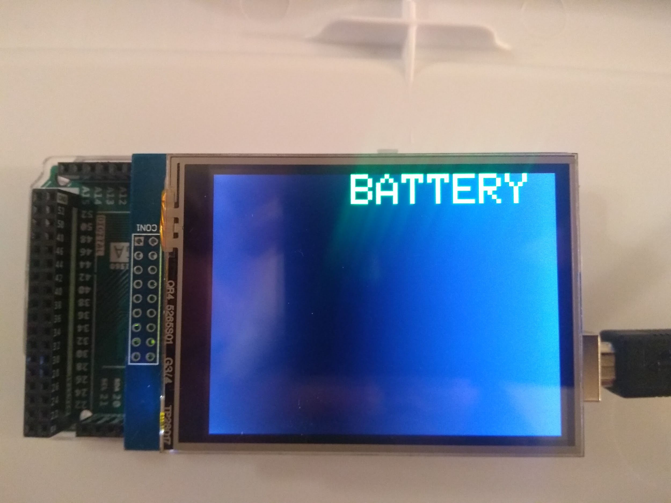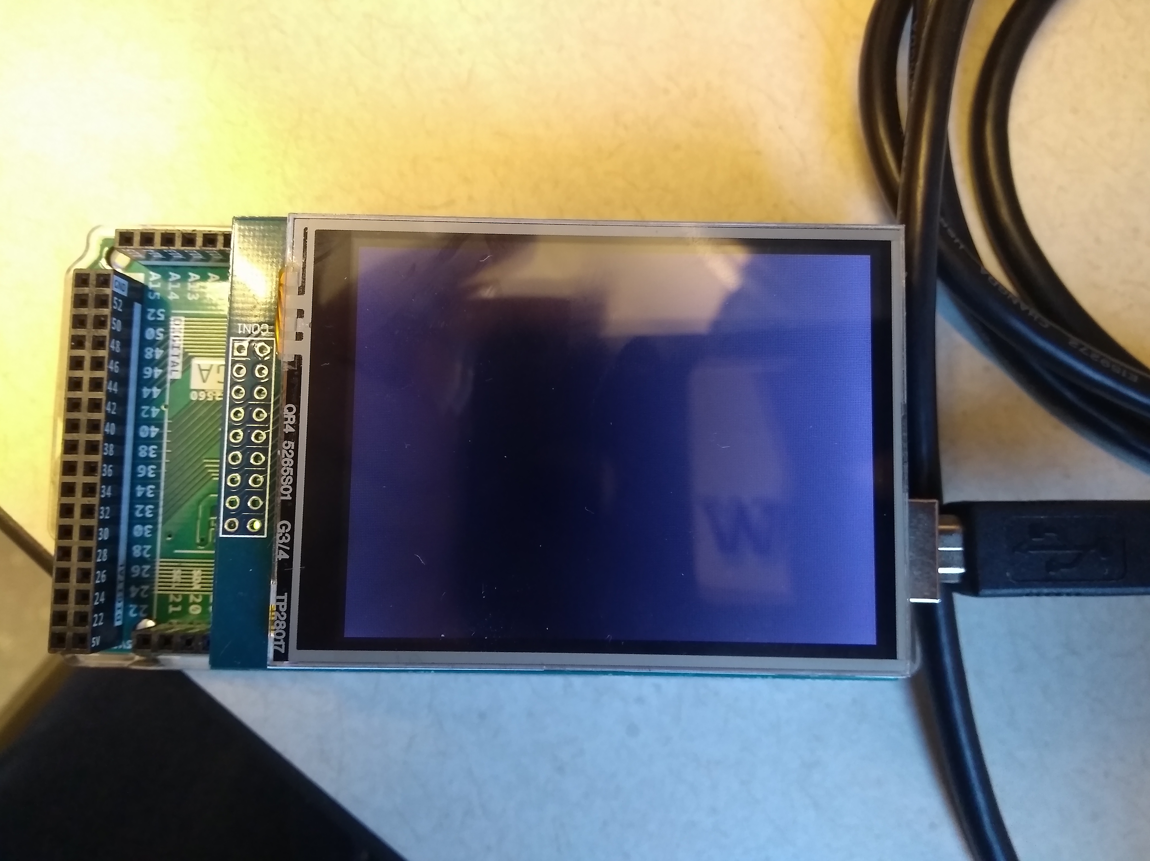

**Case 9. Fuel Flashing Battery >50 Case 10. Fuel Flashing Battery Flashing**

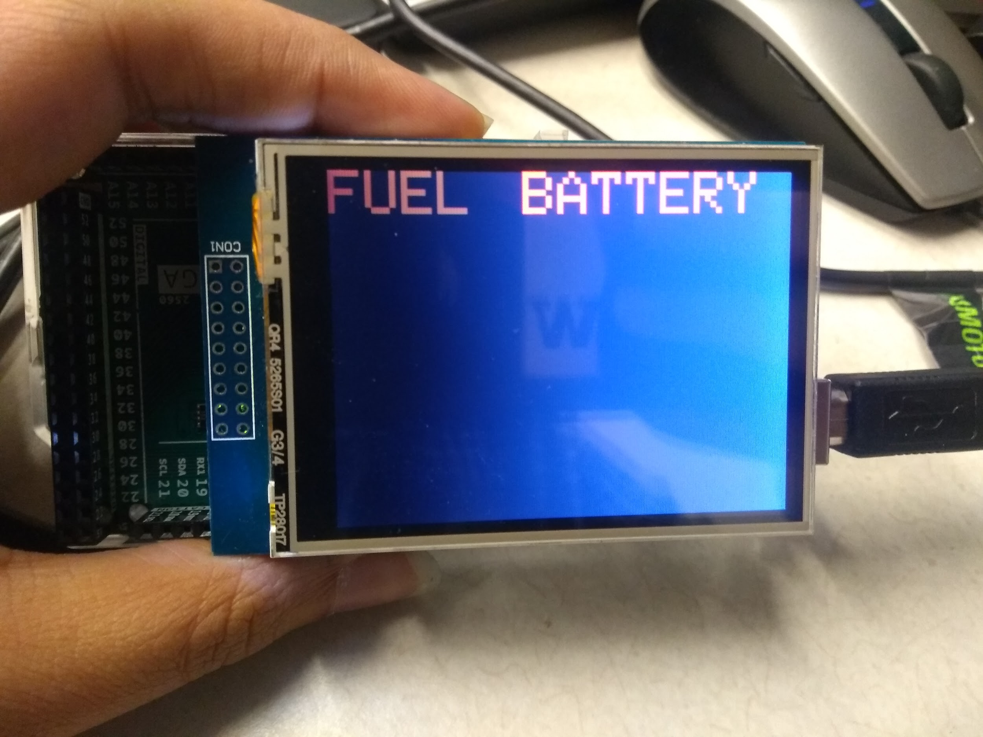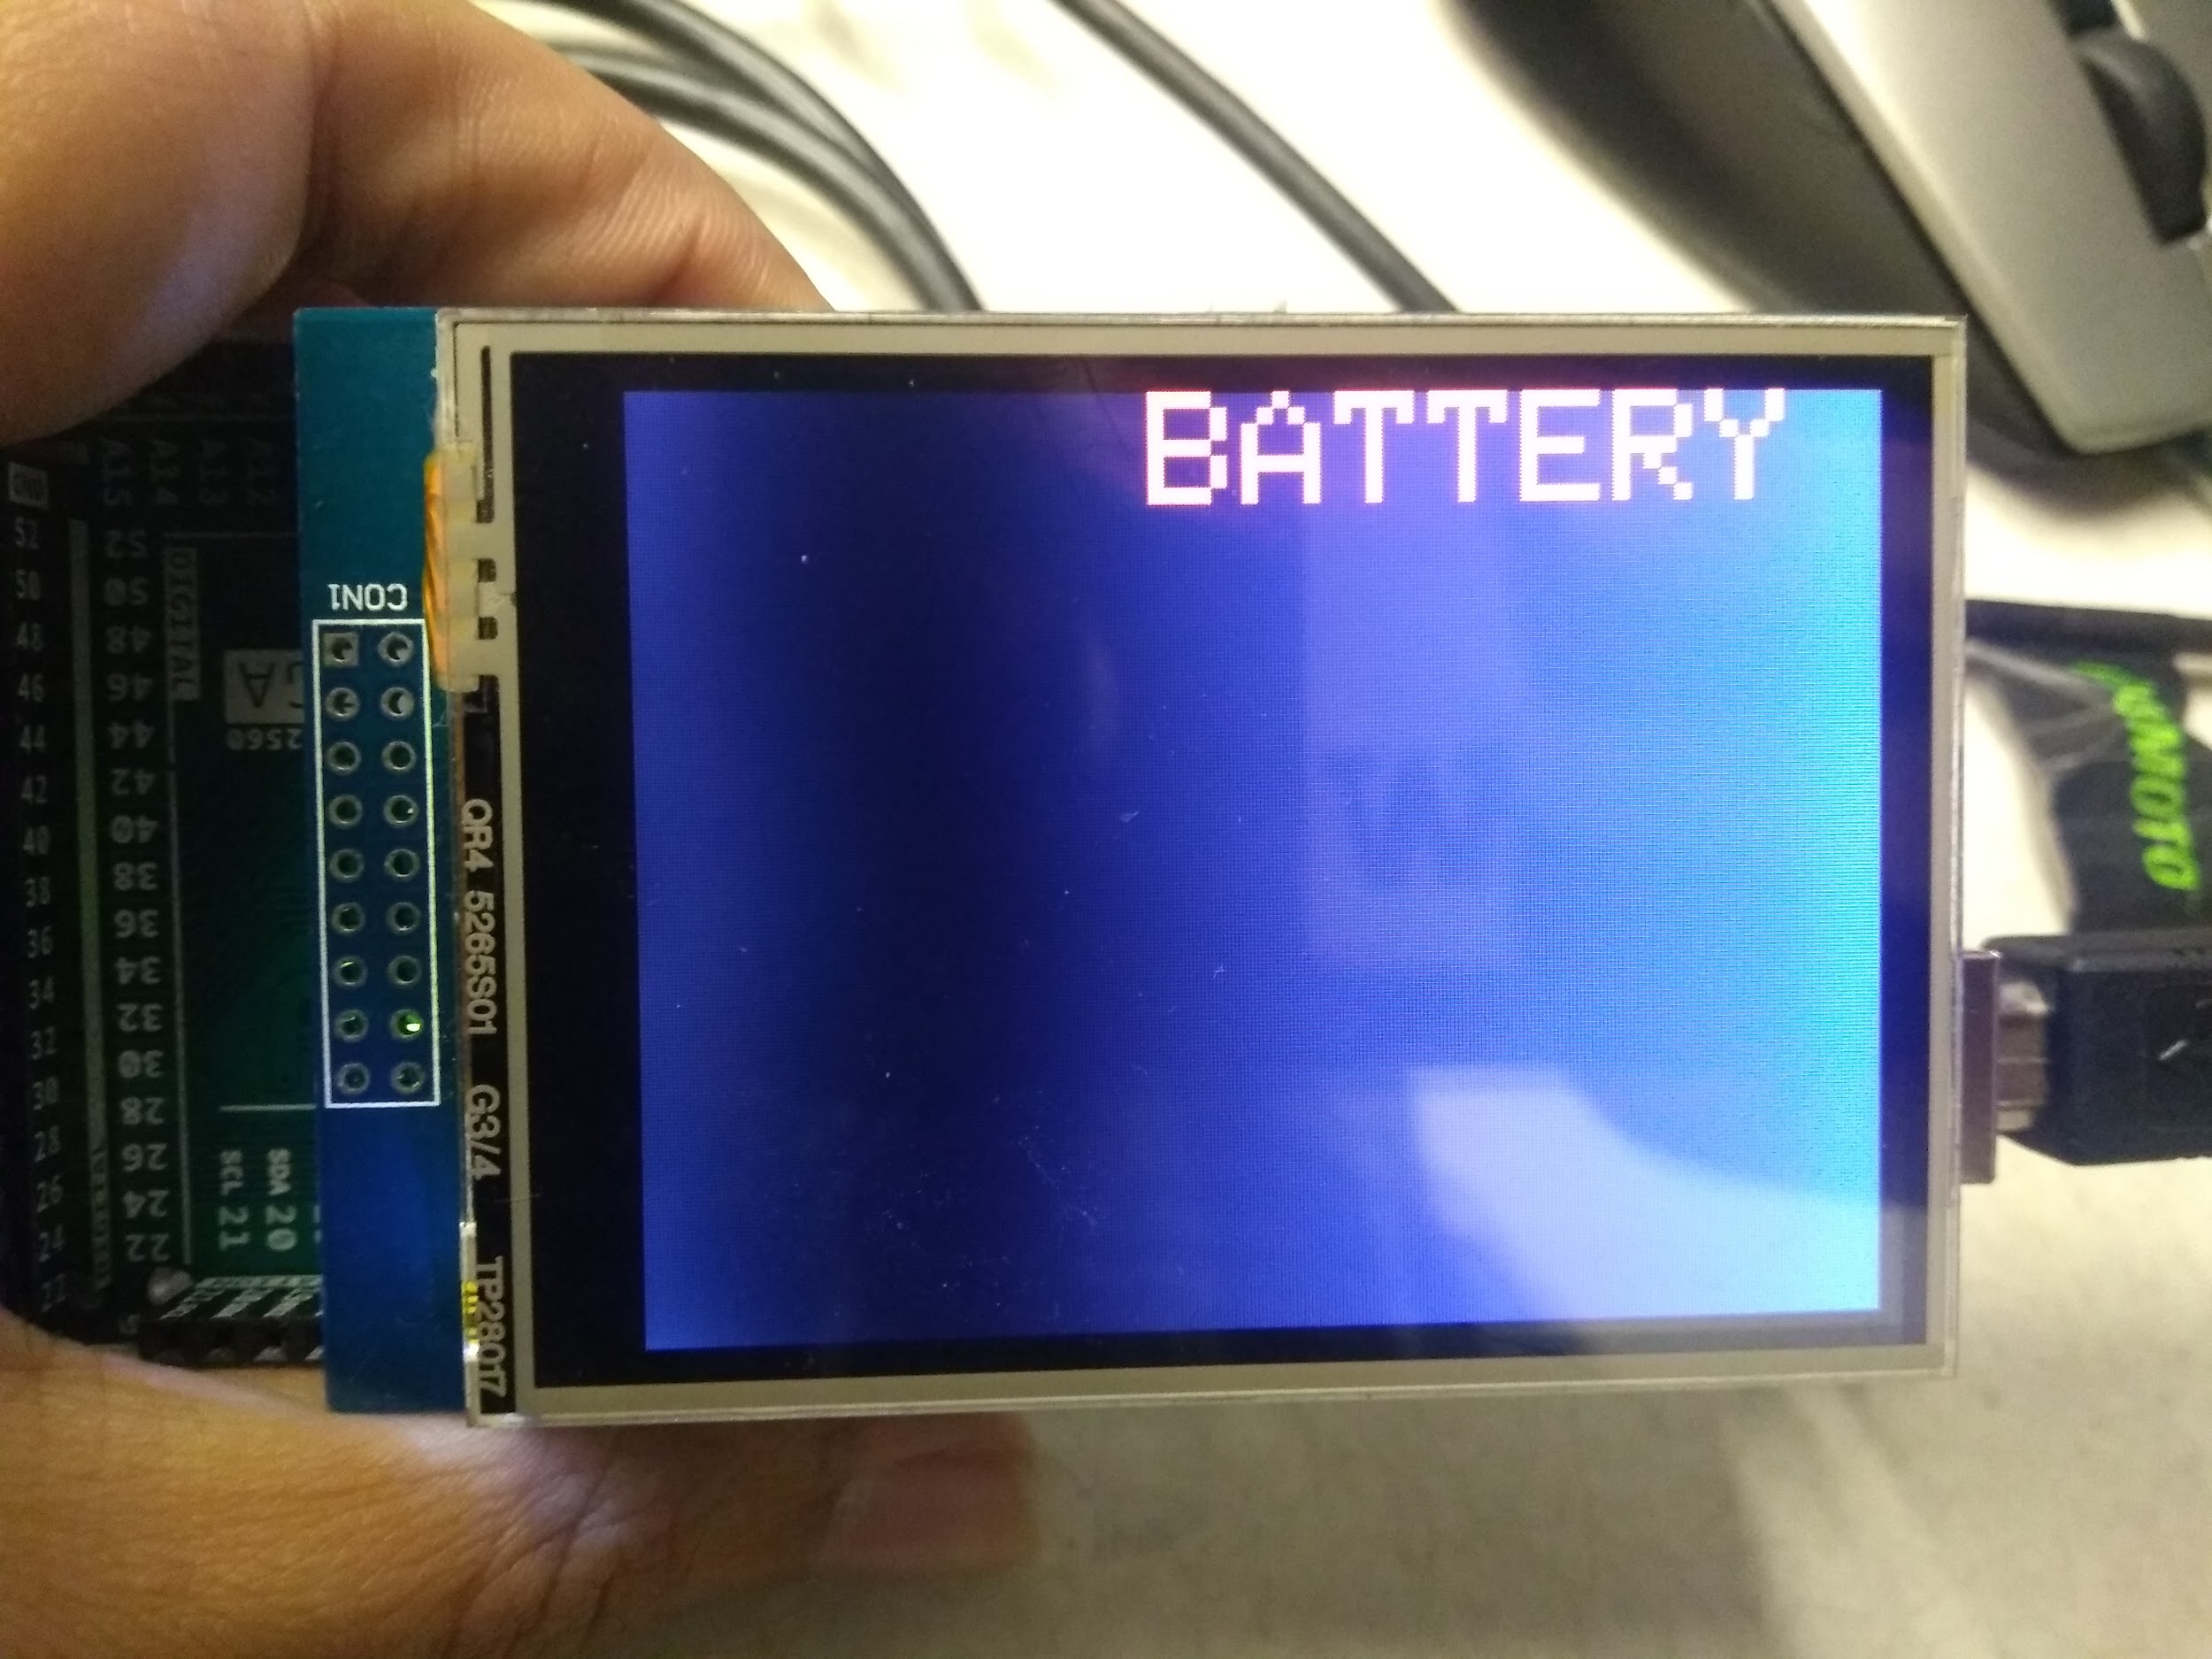

**Case 11: Fuel < 50 and Battery < 50 Case 12: Flashing Fuel Battery <10**

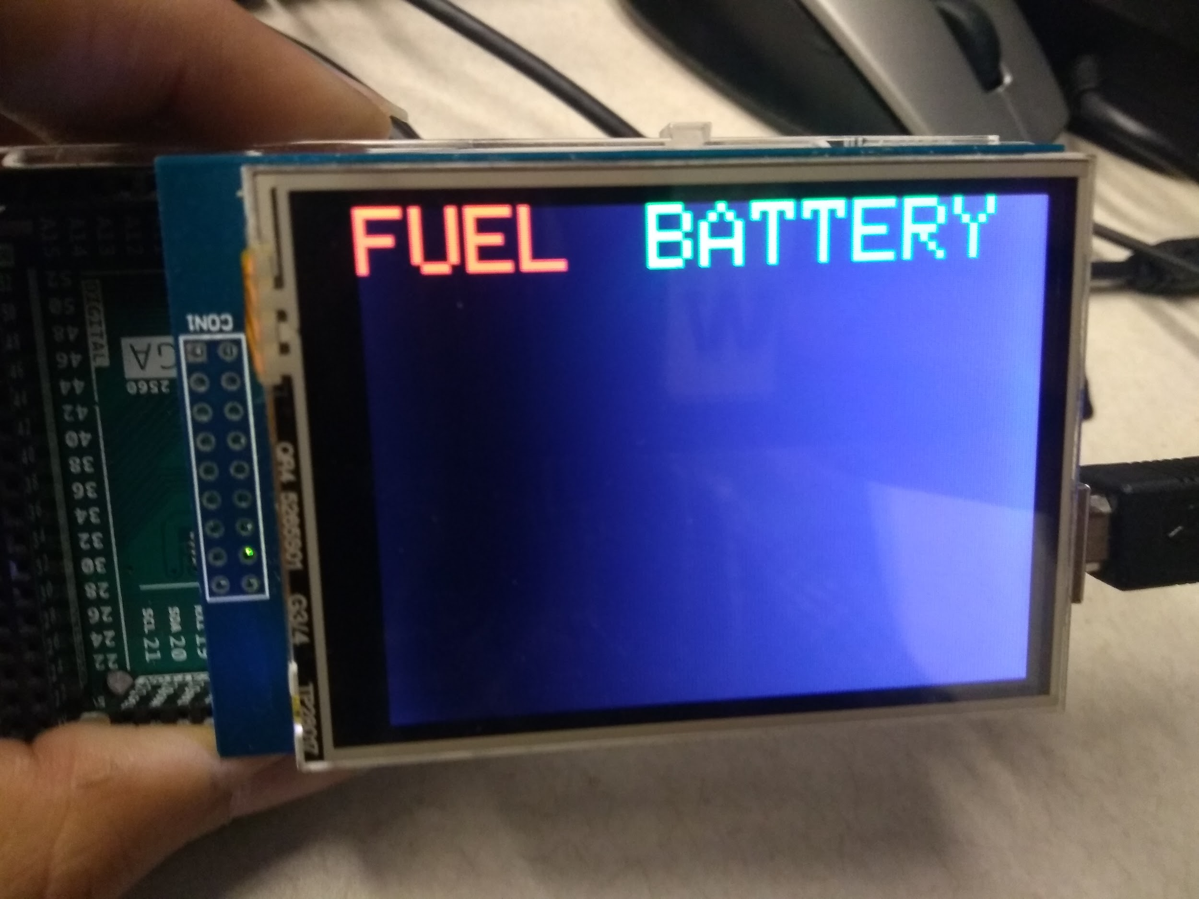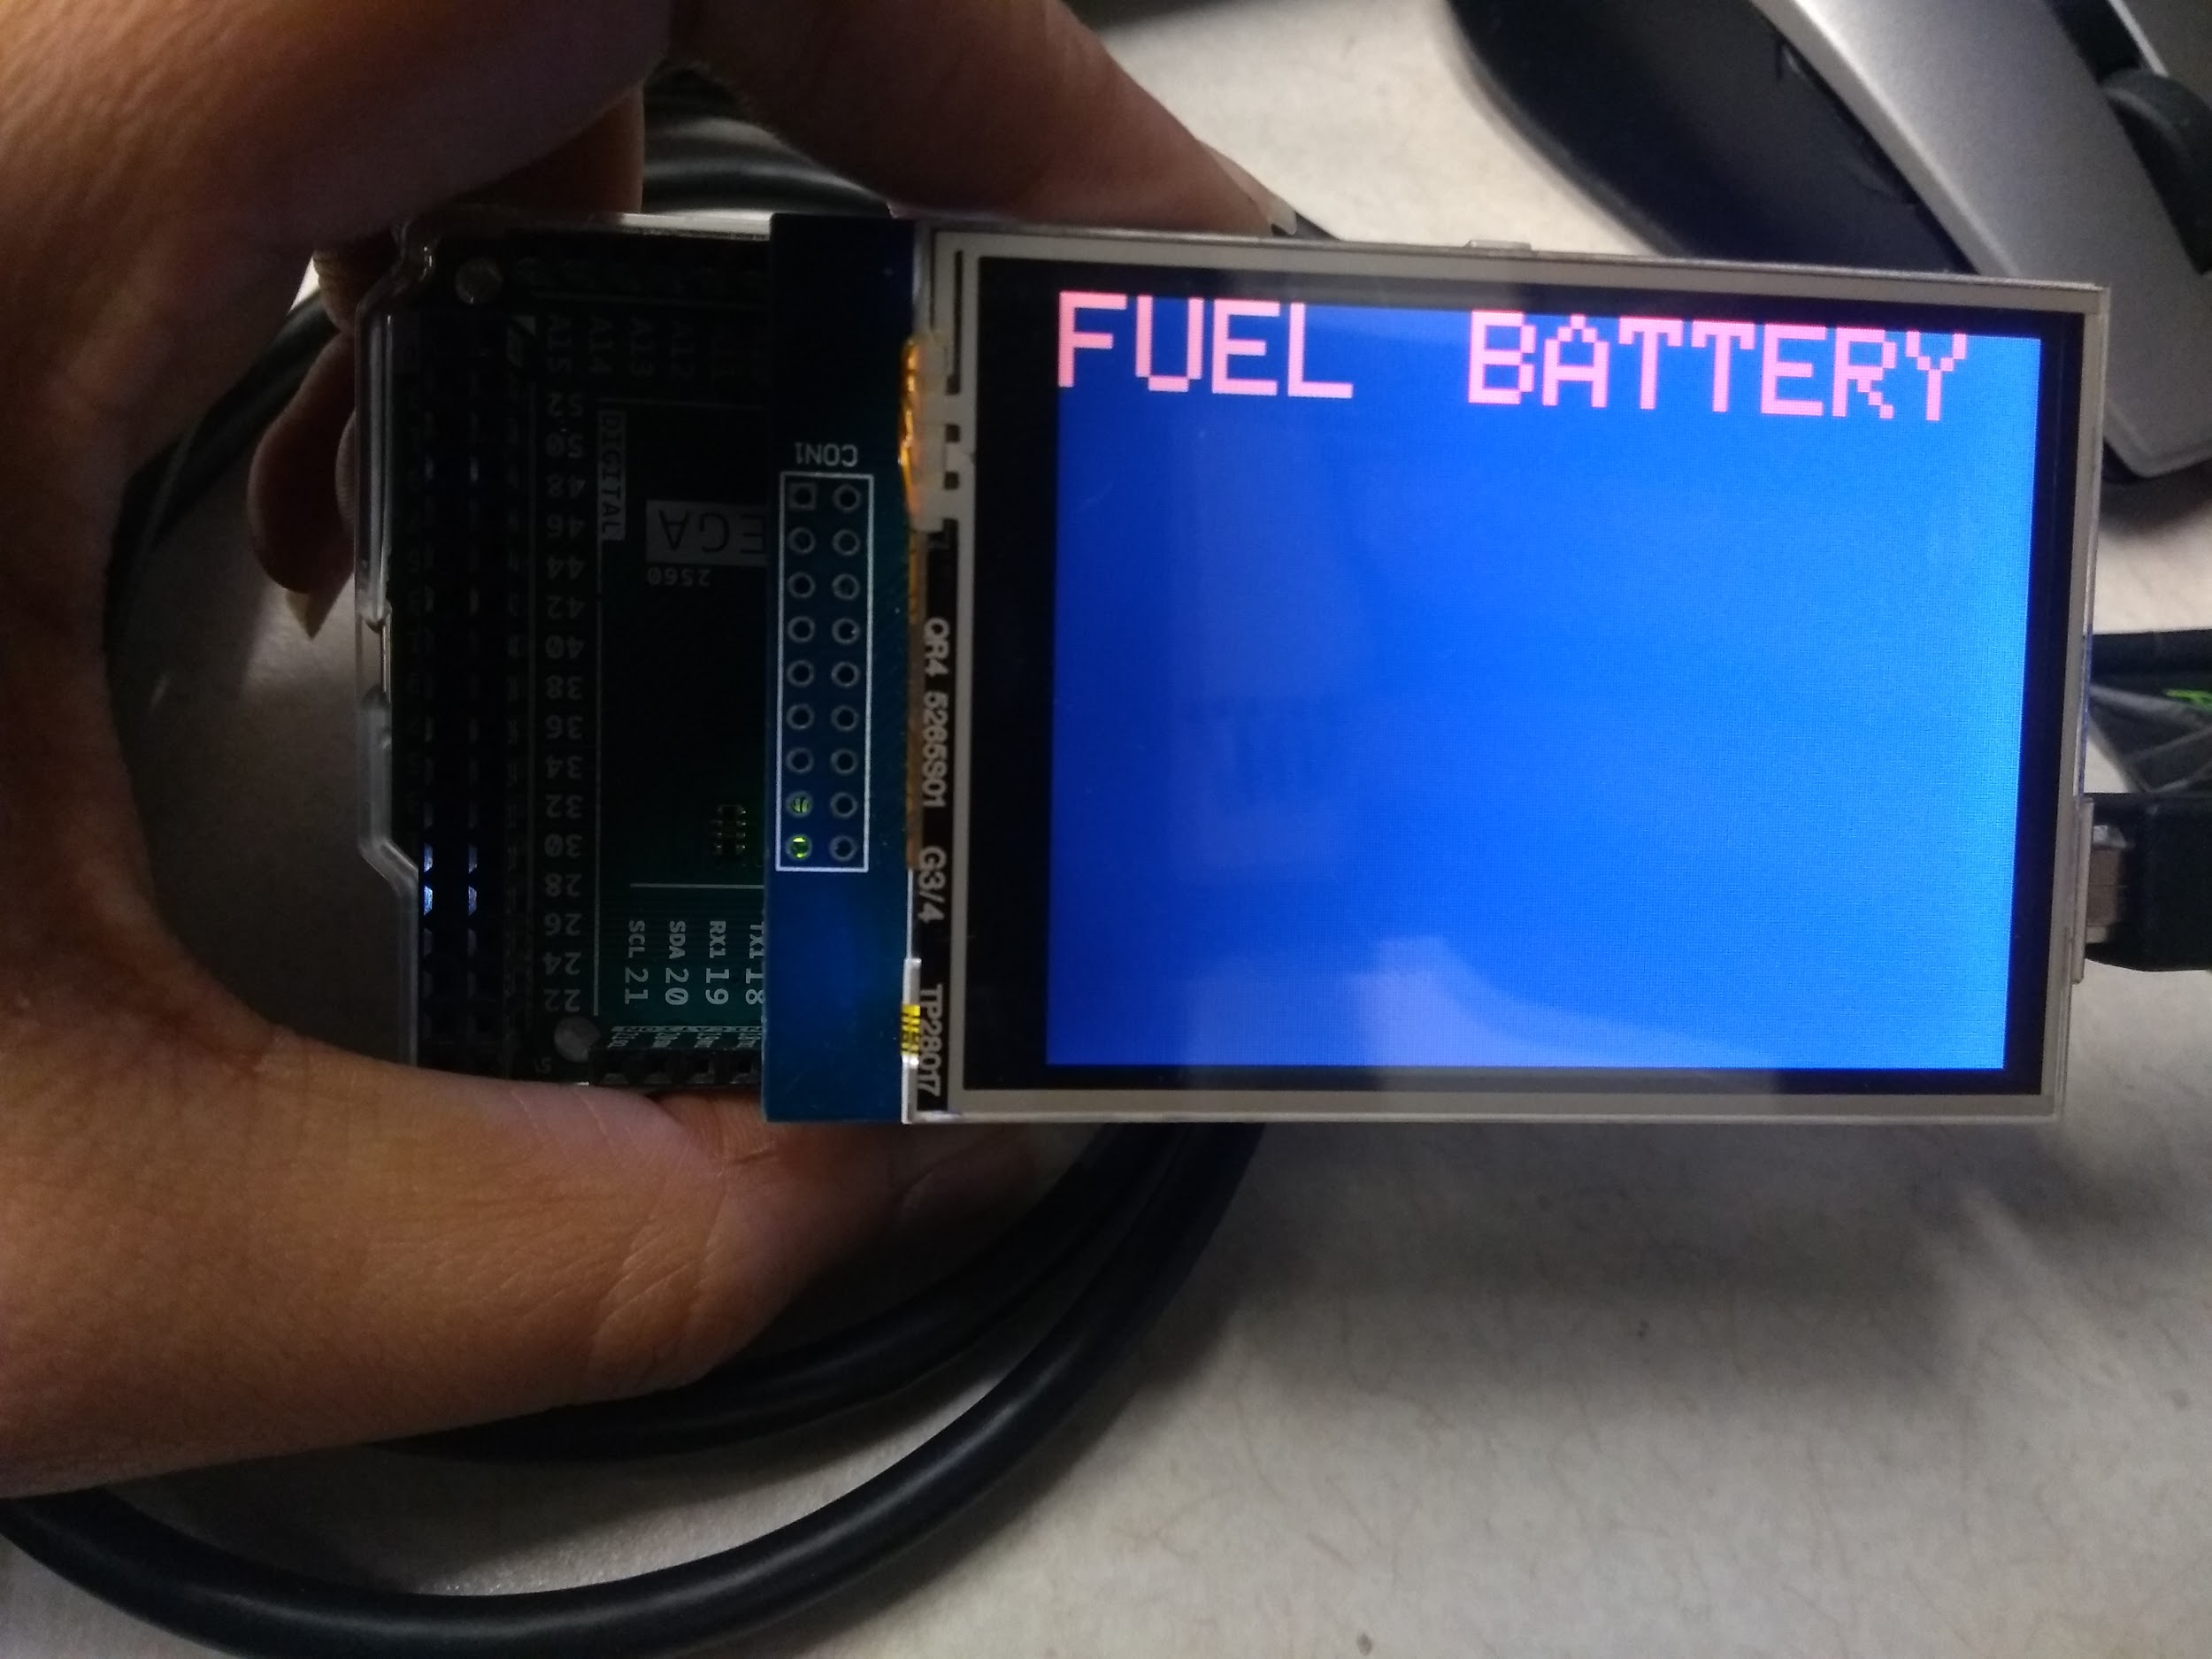

**Case 13. Fuel < 50 and Battery >50 Case 14. Fuel < 50 Battery <10**

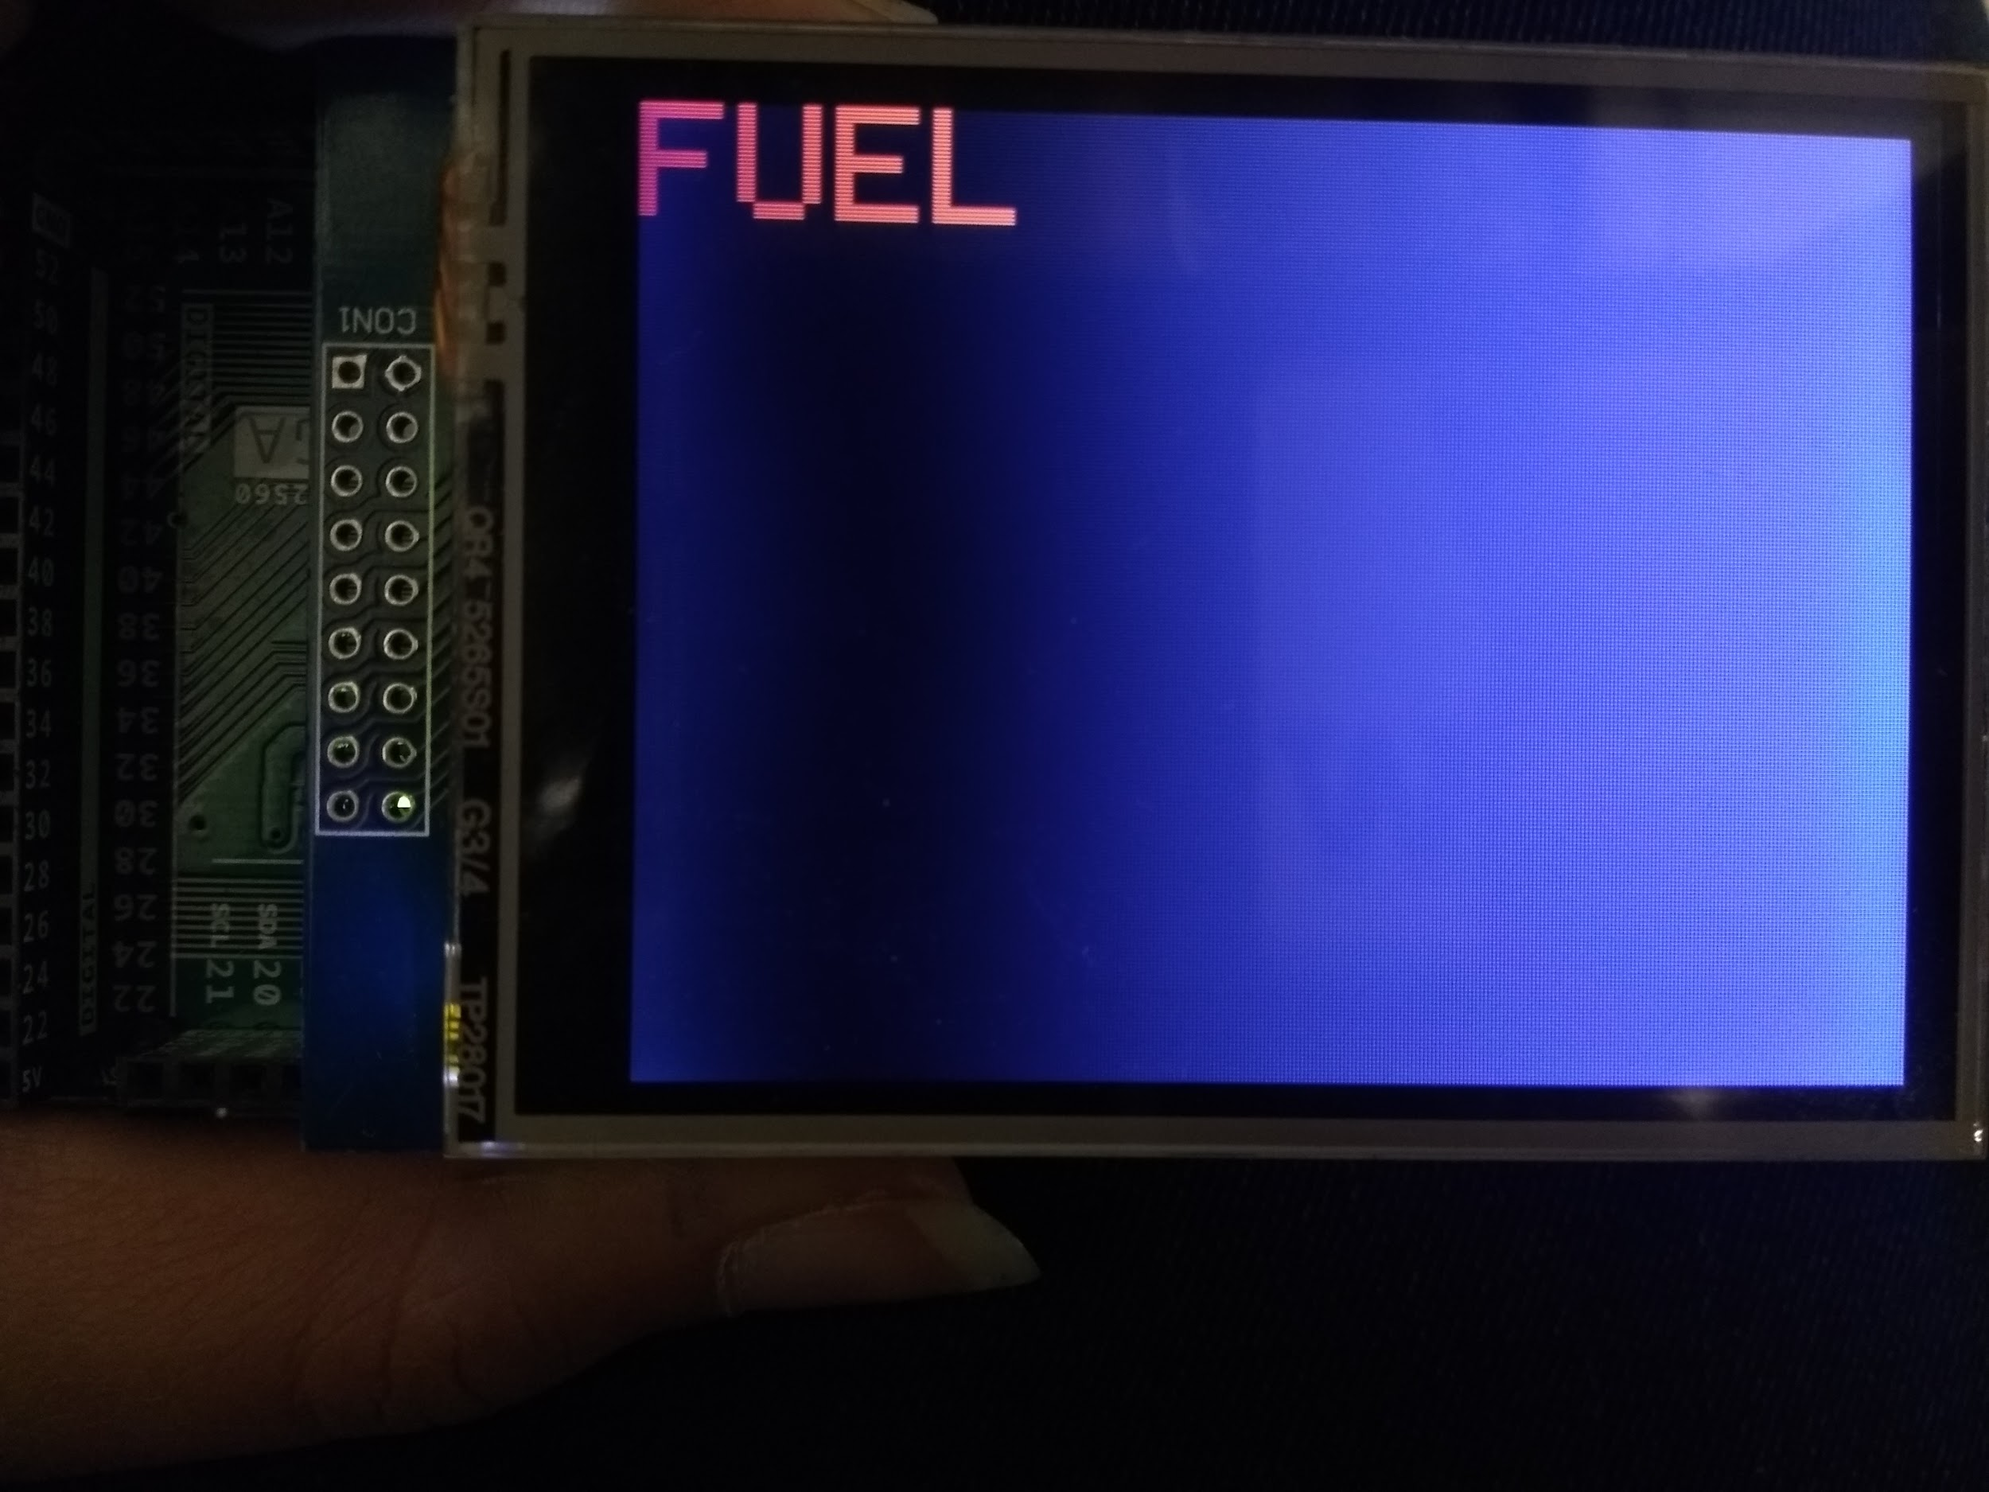

**Case 15. Fuel Orange and Battery Flashing Case 16. Fuel Flashing Battery <10**

**Console Display**

The console display is shown on the Serial Monitor of the ATMega 2560 upon execution of the program. The design of the program is to show the satellite status parameters for two cycles (Solar Panel State, Battery Level, Fuel Level, Power Consumption, and Power Generation), then switch to the Annunciation Display for the next two cycles. This behavior can be seen in Figure 11 below.

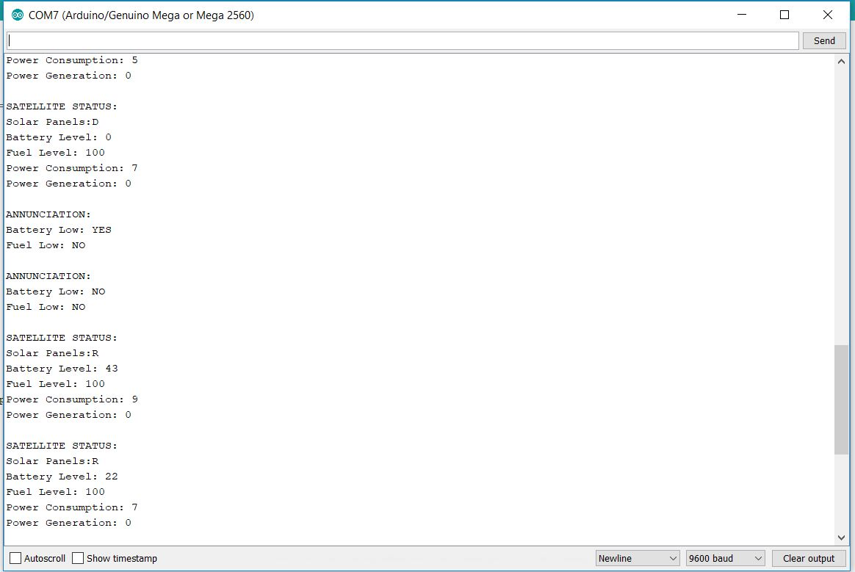

**Figure 11. Console Display : Satellite Status and Annunciation**

**Empirical Analysis of Execution Time**

In order to track execution time of the main task cycle, the user can use the built-in millis command in Arduino to track when execution of each task begins. Since the major cycle of all task execution lasts 5 seconds, there should be close to 5000 milliseconds between the execution of the last task, and the beginning of the first tasks. We empirically capture this timing in Figure 12 below.

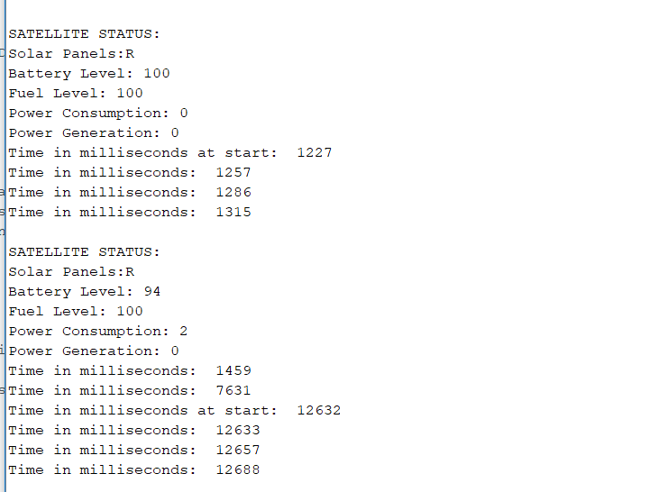

**Figure 12. Scheduler: Empirical Time Analysis**

**ANALYSIS OF ERRORS**

**Logic statements that did not test when fuel level was below 50**

During the demo time slot, the code for the annunciation TFT display was poorly designed, and only could update either the fuel or battery display on the screen, and not both at the same time. The logic was changed for the sake of capturing the screenshots of the display earlier in this report, and these changes can be found in the warningAlarm module of the source code in the Appendices section.

**Setting lower limits to battery level so that when it drops below to zero, it does not spike up to 100**

Overflow of the unsigned short batteryLevel data was occurring when the battery level was less than 3 times the power consumption amount. Since this turns the value below zero since the value is unsigned, it overflows to the maximum value of an unsigned short of 32,767. With logic, when this occurred, battery level would go to 100. This, however posed a problem. This

reflected during the annunciation display on the tft screen where battery level would go straight from red color to green color. To avoid this issue, the unsigned short could have been typecast to another signed data value, and this could freeze the battery level at zero, until the solar panel output power generation can raise the battery level.

**Implementing hardware to switch between satellite status mode and annunciation mode**

Instead of implementing hardware, each mode was displayed in different portions of the cycle to display them at separate times. This is how the user interpreted the requirements of the task, but other options explored by other groups involved using the touch screen capabilities of the TFT display, and also GPIO pins on the ATMega 2560 itself.

**Major Cycle is more than 5 seconds**

When trying to implement the logic to flash FUEL and BATTERY simultaneously at different rates, we kept one loop to display the warning system and the time taken by the loop to run once would be 2 seconds, the loop breaks when the Major Cycle is completed 5 seconds or it does not. For scenarios where there is suppose only 100ms left for the Major cycle to complete the loop will still execute creating a delay of 2000ms causing the Major cycle to be longer. This can be resolved if we add one more statement in the loop check where there is 2 second left for the major cycle to finish or implement a logic inside the loop to break as soon as major cycle is over which seems to be a more efficient way.

**ANALYSIS OF PROBLEMS**

**Implementing Global and Minor Cycles in Arduino**

In the CodeBlocks implementation of this code, a global counter was created to specify the start of the cycle time, and a major counter constant of 5 seconds. If this global counter time was smaller than 5 seconds, all other tasks would not run or update besides the two tasks that displayed the satellite information, and the annunciation TFT display. This code snippet can be found commented out in the source code in the Appendices. In the scope of Arduino, however, this system did not work, or at least it was too late before the demo time to realize that using the millis function can provide a similar system in real time on Arduino.

**TEST PLAN**

Testing the satellite functionality revolves mostly around the use of pointers throughout each method. As specified in the Task Data structs section of the report, each function takes in a pointer that references each of the global variables needed for execution. By verifying that each data struct function takes in the right references to shared global variables, the foundation of each function can be proven.

Not only does each function have to take in the right amount of data, it also has to be able to modify the values in assigned data at a global scale so that these new values are passed into subsequent task cycles.

On an individual task basis, the satellite must be able to print status, warning and annunciation to the Earth station that receives the thruster command.

**TEST SPECIFICATION**

The following global variables are each assigned as: thruster command : 0, battery level : 100, fuel level : 100, power consumption : 0, power generation : 0, solar panel state : false, fuel low : false, and battery low : false.

Major cycle of executing every tasks must take 5 seconds.

**TEST CASES**

**Global variables**

The initial values of thruster command battery level, fuel level , power consumption, power generation, and status of solar panels, fuel and battery are assigned according to the specifications. In order to verify that these global values, initialized in the main method, are passed on to other subsystems, we make print statements in each subsystems. This way, we can test whether or not the pointers inside each method are referencing to the right value. In addition, we test that values changed locally in each methods are passed on to global scales. This is done by making print statements in the main method after we change the value of a global variable inside a subsystems locally.

**Major cycle**

In testing the real duration of the major cycle of our system, we measure the time one cycle started at and the time the next cycle ended at and subtract the later one from the previous one. As seen in figure 12, we use the built in function in arduino to print out the system time at the beginning of each cycle.

**SUMMARY AND CONCLUSION**

From high-level system architecture to each functions of the satellite, this project enables the users to design and implement the development of the overall control flow in the system and drivers that facilitates each satellite tasks. In carrying out this project, fundamentalC structures, various utilizations of structures and pointers are defined and utilized to simulate communication between the satellite and mining vehicle.

This lab was reliant on Arduino ATMega 2560 and TFT display as the only data the satellite was receiving from the mining vehicle was the thruster command was simulated by a random integer. In future labs, we expect data communication between Arduino UNO and ATMega 2560.

The subsystems in this project are the very first of many that will comprise the final system that can collect data from different sources to operate necessary mining tasks as well as communicating with other sources of data . It is important that the design and implementations in this project are clear and well-defined as they will be a stepping stone for building towards a much bigger system in the upcoming projects.

**Time Spent Working on Lab (Hours)**

Design: 5

Coding: 15

Test/Debug: 12

Documentation: 6

**Contributions**

Brian: TCB Queue, Data Structs, Power Subsystem, Satellite Communications

Ben: Console Display, Thruster System

Forum: Arduino Integration, Annunciation TFT Display

**End of Report Questions**

**If a stealth submersible sinks, how do they find it?**

If a stealth submersible sinks, they find it with a stealthy recovery vehicle. You’ll need to take their word on it though. Or attach a string to it.

**Does a helium filled balloon fall or rise south of the equator?**

It will rise, but then drift left due to the Coriolis effect.

**If you fly faster than the speed of sound, do you have to slow down every now and then to let the sound catch up?**

Yes, otherwise when you’d eventually stop, all the sounds will come crashing down upon you.

**If you fly really really fast around the world, can you catch up to the sound before it catches up to you and answer a question before you hear it?**

Yes, but hopefully you understand the question correctly when you catch that sound or else you’ll look foolish.

**If you don’t answer a cell phone call, where does it go? Is it just sitting there waiting for you?**

It goes to your voicemail, which is the same thing. It’ll wait there.

**APPENDICES**

**Function Prototypes**

void consoleDisplayer(void* consoleStruct); // Console Display, takes in parameter of consoleData struct

void powerSystem(void* powerStruct); // updates power-related data, takes in parameter of powerSubsystemData struct

void thrusterSystem(void* thrustStruct); // updates thruster-related data, takes in parameter to thrusterSubsystemData struct

void warningSystem(void* alarmStruct); // updates warning display for fuel and battery applications, takes in parameter of alarmData struct

void satelliteCommSystem(void* satelliteStruct); // creates thruster command to be used by the rest of the application cycle, takes in parameter of satelliteSubsystemData struct

**Task Data Structs**

typedef struct powerSubystemData { // pointers to access values for power subsystem

Bool *solarPanelState;

unsigned short *batteryLevel;

unsigned short *powerConsumption;

unsigned short *powerGeneration;

} powerData;

typedef struct thrusterSubsystemData { // pointers to access values for thruster subsystem

unsigned int *thrusterCommand;

unsigned short *fuelLevel;

} thrusterData;

typedef struct satelliteComsData { // pointers to access values for satellite communications subsystem

Bool *fuelLow;

Bool *batteryLow;

Bool *solarPanelState;

unsigned short *batteryLevel;

unsigned short *fuelLevel;

unsigned short *powerConsumption;

unsigned short *powerGeneration;

unsigned int *thrusterCommand;

} satelliteData;

typedef struct consoleDisplayData { // pointers to access values to print onto console display subsystem

Bool *fuelLow;

Bool *batteryLow;

Bool *solarPanelState;

unsigned short *batteryLevel;

unsigned short *fuelLevel;

unsigned short *powerConsumption;

unsigned short *powerGeneration;

} displayData;

typedef struct warningAlarmData { // pointers to access values needed to determine warning alarm state

Bool *fuelLow;

Bool *batteryLow;

unsigned short *batteryLevel;

unsigned short *fuelLevel;

} alarmData;

**Pseudo Code**

**Console Display**

printf(

Satellite Status mode:

solar panel state

battery level

fuel level

power consumption)

printf(

Annunciation mode:

display:

fuel low

battery low)

**Warning Alarm**

if (fuellvl > 50 && batterylvl > 50),

display solid green "Fuel" and "Battery" on annunciation panel

else if battery level <= 50

"Battery" on annuciation panel Orange and flash at 1s rate

else if fuel level <= 50

"Fuel" on annunciation panel Orange and flash at 2s rate

else if battery level <= 10

"Battery" rRED fash at 1s rate

else if fuel level <= 10

"Fuel" RED flash at 2s rate

**Power System**

void powerSystem(void *powerStruct)

consumption = consumption + 2 every even numbered time

consumption = consumption - 1 every odd numbered time

at consumption = 10

reverse:

consumption = consumption - 1 every even umbered time

consumption = consumption +2 every odd numbered time

until at 5, reverse again

if solar panel = true

if batterylevel > 95

retract solar panel

else

if batterylevel < 50

+2 every even numbered time

+1 every odd numbered time

else

if batterylevel < 95

+2 every even numbererd time called

else

if batteryLevel <= 10

deploy solar panel

else

do nothing

Battery level

if solar panel is not deployed

each time called: compute batteryLevel = batteryLevel - 3*powerConsumption

else

each time called: compute batteryLevel = batteryLevel - powerConsumption + powerGeneration

**Thruster Subsystem**

(*thrusterCommand = 16bit number, Direction: Bits 0-3, Magnitude:Bits 4-7, Duration: Bits 8-15)

// calculate fuel cost of individual thruster command by multiplying magnitude and duration

if(fuelLevel == 0){

// print “Out of Fuel”, and exit the loop

} else {

// subtract fuel level from fuel cost

}

**SatelliteCommSystem**

*currentThrusterCommand = random integer from random integer generator

uint16_t correctDirectionFactor = (assign masking factor)

*currentThrusterCommand &= correctDirectionFactor; // bitwise AND the thruster command so that direction (bits 0-3) will always be a number between 0 and 3.

**Source Code**

#include <stdio.h>

#include <stdlib.h>

#include <unistd.h>

#include <limits.h>

#define MC 10000000

**TFT Display Setup**

// IMPORTANT: ELEGOO_TFTLCD LIBRARY MUST BE SPECIFICALLY

// CONFIGURED FOR EITHER THE TFT SHIELD OR THE BREAKOUT BOARD.

// SEE RELEVANT COMMENTS IN Elegoo_TFTLCD.h FOR SETUP.

//Technical support:goodtft@163.com

#include <Elegoo_GFX.h> // Core graphics library

#include <Elegoo_TFTLCD.h> // Hardware-specific library

// The control pins for the LCD can be assigned to any digital or

// analog pins...but we'll use the analog pins as this allows us to

// double up the pins with the touch screen (see the TFT paint example).

#define LCD_CS A3 // Chip Select goes to Analog 3

#define LCD_CD A2 // Command/Data goes to Analog 2

#define LCD_WR A1 // LCD Write goes to Analog 1

#define LCD_RD A0 // LCD Read goes to Analog 0

#define LCD_RESET A4 // Can alternately just connect to Arduino's reset pin

// When using the BREAKOUT BOARD only, use these 8 data lines to the LCD:

// For the Arduino Uno, Duemilanove, Diecimila, etc.:

// D0 connects to digital pin 8 (Notice these are

// D1 connects to digital pin 9 NOT in order!)

// D2 connects to digital pin 2

// D3 connects to digital pin 3

// D4 connects to digital pin 4

// D5 connects to digital pin 5

// D6 connects to digital pin 6

// D7 connects to digital pin 7

// For the Arduino Mega, use digital pins 22 through 29

// (on the 2-row header at the end of the board).

// Assign human-readable names to some common 16-bit color values:

#define BLACK 0x0000

#define BLUE 0x001F

#define RED 0xF800

#define GREEN 0x07E0

#define CYAN 0x07FF

#define MAGENTA 0xF81F

#define YELLOW 0xFFE0

#define WHITE 0xFFFF

#define ORANGE 0xAA60

Elegoo_TFTLCD tft(LCD_CS, LCD_CD, LCD_WR, LCD_RD, LCD_RESET);

//enum myBool { false = 0, true = 1 };

//typedef enum myBool Bool;

//Initializing variables for Time scheduling

extern unsigned long GC; // Global Counter

unsigned long time1; //variable to store system time

unsigned long GC = 0; // initialize Global counter to zero

**Data Structs**

// Data structure with pointer variables for the function powerSystem

struct powerData {

bool *solarPanelState;

unsigned short *batteryLevel;

unsigned short *powerConsumption;

unsigned short *powerGeneration;

} ;

// Data structure with pointer variables for the function thrusterSystem

struct thrusterData {

unsigned int *thrusterCommand;

unsigned short *fuelLevel;

} ;

// Data structure with pointer variables for the function SatelliteCommSystem

struct satelliteData {

bool *fuelLow;

bool *batteryLow;

bool *solarPanelState;

unsigned short *batteryLevel;

unsigned short *fuelLevel;

unsigned short *powerConsumption;

unsigned short *powerGeneration;

unsigned int *thrusterCommand;

} ;

// Data structure with pointer variables for the function consoleDisplayer

struct displayData {

bool *fuelLow;

bool *batteryLow;

bool *solarPanelState;

unsigned short *batteryLevel;

unsigned short *fuelLevel;

unsigned short *powerConsumption;

unsigned short *powerGeneration;

} ;

// Data structure with pointer variables for the function warningSystem

struct alarmData {

bool *fuelLow;

bool *batteryLow;

unsigned short *batteryLevel;

unsigned short *fuelLevel;

} ;

// Data structure with task and data pointers that points to a function and its data

struct TCB //Data structure of Task Control Block

{

void *taskDataPtr;

void (*taskPtr)(void*);

};

**Main Setup Code**

//Initializing all Function blocks

void consoleDisplayer(void* consoleStruct);

void powerSystem(void* powerStruct);

void thrusterSystem(void* thrusterStruct);

void warningSystem(void* alarmStruct);

void satelliteCommSystem(void* satelliteStruct);

//Initializing global input variables

unsigned int thrusterCommand = 0;

unsigned short batteryLevel = 100;

unsigned short fuelLevel = 100;

unsigned short powerConsumption = 0;

unsigned short powerGeneration = 0;

bool solarPanelState = false;

bool fuelLow = false;

bool batteryLow = false;

//Initializing TCB queue

TCB* queue[6];

// Creating Tasks of type TCB data structures

TCB powerSubsystem;

TCB thrusterSubsystem;

TCB satelliteCommunications;

TCB consoleDisplay;

TCB warningAlarm;

//Pointer to the TCB data structure

TCB* aTCBPtr;

// initialize instances of data structs used to track data in each task

powerData myPowerSubsystemData;

thrusterData myThrusterSubsystemData;

satelliteData mySatelliteSubsystemData;

displayData myDisplayData;

alarmData myAlarmData;

//Function for initial setup

void setup() {

Serial.begin(9600); // Initialize Serial Terminal

//Initializing the TFT

#ifdef USE_Elegoo_SHIELD_PINOUT

Serial.println(F("Using Elegoo 2.4\" TFT Arduino Shield Pinout"));

#else

Serial.println(F("Using Elegoo 2.4\" TFT Breakout Board Pinout"));

#endif

Serial.print("TFT size is "); Serial.print(tft.width()); Serial.print("x"); Serial.println(tft.height());

tft.reset();

uint16_t identifier = tft.readID();

if(identifier == 0x9325) {

Serial.println(F("Found ILI9325 LCD driver"));

} else if(identifier == 0x9328) {

Serial.println(F("Found ILI9328 LCD driver"));

} else if(identifier == 0x4535) {

Serial.println(F("Found LGDP4535 LCD driver"));

}else if(identifier == 0x7575) {

Serial.println(F("Found HX8347G LCD driver"));

} else if(identifier == 0x9341) {

Serial.println(F("Found ILI9341 LCD driver"));

} else if(identifier == 0x8357) {

Serial.println(F("Found HX8357D LCD driver"));

} else if(identifier==0x0101)

{

identifier=0x9341;

Serial.println(F("Found 0x9341 LCD driver"));

}

else if(identifier==0x1111)

{

identifier=0x9328;

Serial.println(F("Found 0x9328 LCD driver"));

}

else {

Serial.print(F("Unknown LCD driver chip: "));

Serial.println(identifier, HEX);

Serial.println(F("If using the Elegoo 2.8\" TFT Arduino shield, the line:"));

Serial.println(F(" #define USE_Elegoo_SHIELD_PINOUT"));

Serial.println(F("should appear in the library header (Elegoo_TFT.h)."));

Serial.println(F("If using the breakout board, it should NOT be #defined!"));

Serial.println(F("Also if using the breakout, double-check that all wiring"));

Serial.println(F("matches the tutorial."));

identifier=0x9328;

}

tft.begin(identifier);

tft.fillScreen(BLACK); // Set TFT screen to black

// define queue of TCB subtasks, as well as pointer to access TCB elements

// initialize data pointers to specific global variables

myPowerSubsystemData.batteryLevel = &batteryLevel;

myPowerSubsystemData.powerConsumption = &powerConsumption;

myPowerSubsystemData.powerGeneration = &powerGeneration;

myPowerSubsystemData.solarPanelState = &solarPanelState;

myThrusterSubsystemData.fuelLevel = &fuelLevel;

myThrusterSubsystemData.thrusterCommand = &thrusterCommand;

mySatelliteSubsystemData.batteryLevel = &batteryLevel;

mySatelliteSubsystemData.batteryLow = &batteryLow;

mySatelliteSubsystemData.fuelLevel = &fuelLevel;

mySatelliteSubsystemData.fuelLow = &fuelLow;

mySatelliteSubsystemData.powerConsumption = &powerConsumption;

mySatelliteSubsystemData.powerGeneration = &powerGeneration;

mySatelliteSubsystemData.solarPanelState = &solarPanelState;

mySatelliteSubsystemData.thrusterCommand = &thrusterCommand;

myDisplayData.batteryLevel = &batteryLevel;

myDisplayData.batteryLow = &batteryLow;

myDisplayData.fuelLevel = &fuelLevel;

myDisplayData.fuelLow = &fuelLow;

myDisplayData.powerConsumption = &powerConsumption;

myDisplayData.powerGeneration = &powerGeneration;

myDisplayData.solarPanelState = &solarPanelState;

myAlarmData.batteryLevel = &batteryLevel;

myAlarmData.batteryLow = &batteryLow;

myAlarmData.fuelLevel = &fuelLevel;

myAlarmData.fuelLow = &fuelLow;

// Initialize TCB's to point to data structure, as well as method name

powerSubsystem.taskDataPtr = (void*)&myPowerSubsystemData;

powerSubsystem.taskPtr = powerSystem;

thrusterSubsystem.taskDataPtr = (void*)&myThrusterSubsystemData;

thrusterSubsystem.taskPtr = thrusterSystem;

satelliteCommunications.taskDataPtr = (void*)&mySatelliteSubsystemData;

satelliteCommunications.taskPtr = satelliteCommSystem;

consoleDisplay.taskDataPtr = (void*)&myDisplayData;

consoleDisplay.taskPtr = consoleDisplayer;

warningAlarm.taskDataPtr = (void*)&myAlarmData;

warningAlarm.taskPtr = warningSystem;

// Set TCB in queue, specifying order

queue[0] = &satelliteCommunications;

queue[1] = &thrusterSubsystem;

queue[2] = &powerSubsystem;

queue[3] = &consoleDisplay;

queue[4] = &warningAlarm;

consoleDisplayer(myDisplayData);

//To run the Console Display Task once, to display Initial data

aTCBPtr = queue[3];

aTCBPtr->taskPtr( (aTCBPtr->taskDataPtr));

}

**Task Queue Loop**

void loop() {

//Serial.print("In void loop");

// time1 is set to be in between 1- 5000ms for the timer to execute 1 major cycle of 5 seconds

time1 = millis()%5000;

for (int i = 0; i < 5; i++) {

aTCBPtr = queue[i]; // Pick a task form the queue sequentially

// fetch the data and function of the task into the TCB and execute the task

aTCBPtr->taskPtr( (aTCBPtr->taskDataPtr));

time1 = millis()%5000;

/* if (i == 4) {

if (GC % MC == 0) {

delay(5000);

}

GC++;

}*/

}

}

**Console Display**

//Function for displaying Data on the Console.

void consoleDisplayer(void * consoleStruct) {

//Serial.print("consoleDisplayer\n");

/*static unsigned long count = 0;

if ((GC - count) % MC != 0 ) {

return;

}

count = GC;*/

// pass in console display data struct and assign pointers to global values.

displayData *dData = (displayData*) consoleStruct;

bool *solarPanelState = dData->solarPanelState;

bool *fuelLow = dData->fuelLow;

bool *batteryLow = dData->batteryLow;

unsigned short *batteryLevel = dData->batteryLevel;

unsigned short *fuelLevel = dData->fuelLevel;

unsigned short *powerConsumption = dData->powerConsumption;

unsigned short *powerGeneration = dData->powerGeneration;

char *solarpanelPrint = (*solarPanelState) ? "Deployed" : "Retracted";

char *fuelStatePrint = (*fuelLow) ? "YES" : "NO";

char *batteryStatePrint = (*batteryLow) ? "YES" : "NO";

// create counter to measure cycles of execution

static int currentDisplayCycles = 0;

if (currentDisplayCycles % 4 == 0 || currentDisplayCycles % 4 == 1) { // first two cycles through task queue

//if (toggleDisplay == 1){

Serial.print("\nSATELLITE STATUS: \nSolar Panels:");

Serial.print(*solarpanelPrint);

Serial.print("\nBattery Level: ");

Serial.print(*batteryLevel);

Serial.print("\nFuel Level: ");

Serial.print( *fuelLevel);

Serial.print("\nPower Consumption: ");

Serial.print(*powerConsumption);

Serial.print("\nPower Generation: ");

Serial.print(*powerGeneration);

Serial.print("\n") ;

printf("SATELLITE STATUS: \n"

"Solar Panels: %9s\n "

"Battery Level: %3hu\n "

"Fuel Level: %3hu\n "

"Power Consumption: %2hu\n "

"Power Generation: %2hu\n",

solarpanelPrint, *batteryLevel, *fuelLevel, *powerConsumption, *powerGeneration);

} else { // display annunciation display every third and fourth cycle.

Serial.print("\nANNUNCIATION: \nBattery Low: ");

Serial.print(batteryStatePrint);

Serial.print("\nFuel Low: ");

Serial.print(fuelStatePrint);

Serial.print("\n");

printf("ANNUNCIATION:\n "

"Battery Low: %3s\n "

"Fuel Low: %3s\n\n",

batteryStatePrint, fuelStatePrint);

}

currentDisplayCycles ++;

}

**Power System**

// function prototypes for functions used inside main powerSystem function

void updatePowerConsumption(unsigned short *currentConsumptionLevel);

void updatePowerGeneration(bool *solarPanelState, unsigned short *currentGenerationLevel, unsigned short *batteryLevel);

void updateBatteryLevel(bool *solarPanelState, unsigned short *currentConsumptionLevel, unsigned short *currentGenerationLevel, unsigned short *batteryLevel);

void powerSystem (void* powerStruct) {

// get data from pointers in data struct for use in method.

//Serial.print("powerSystem\n");

/*static unsigned long count = 0;

if ((GC - count) % MC != 0 ) {

return;

}

count = GC;

*/

powerData *myPowerData = (powerData*)powerStruct;

unsigned short *batteryLevel = myPowerData->batteryLevel;

unsigned short *powerConsumptionLevel = myPowerData->powerConsumption;

unsigned short *powerGenerationLevel = myPowerData->powerGeneration;

bool *solarPanelState = myPowerData->solarPanelState;

// list of three methods to update power-related variables.

updatePowerConsumption(powerConsumptionLevel);

updatePowerGeneration(solarPanelState, powerGenerationLevel, batteryLevel);

updateBatteryLevel(solarPanelState, powerConsumptionLevel, powerGenerationLevel, batteryLevel);

}

void updatePowerGeneration(bool *solarPanelState, unsigned short *currentGenerationLevel, unsigned short *batteryLevel) {

//Serial.print("updatePowerGeneration\n");

static int currentGenerationCycles = 0; // set static variable to record what iteration cycle is occurring in the method.

if (*solarPanelState == true) {

if (*batteryLevel > 95) {

*solarPanelState = false;

*currentGenerationLevel = 0;

} else {

if (*batteryLevel <= 50) {

if (currentGenerationCycles % 2 == 0) {

*currentGenerationLevel += 2; // up 2 every even cycle

} else {

*currentGenerationLevel += 1; // up 1 every off cycle

}

} else {

if (*batteryLevel <= 95) {

if (currentGenerationCycles % 2 == 0) {

*currentGenerationLevel += 2; // up 2 every even cycle

}

}

}

}

} else {

if (*batteryLevel <= 10) {

*solarPanelState = true;

}

}

currentGenerationCycles++; // continually increment static variable for cycle count

}

void updatePowerConsumption(unsigned short *currentConsumptionLevel) {

// set static variable to record what iteration cycle is occurring in the variable.

// Serial.print("updatePowerConsumption\n");

static int currentConsumptionCycles = 0;

static bool reverseDirection = false; // initial value to false of below5 will increment to ten, and

if (!reverseDirection) {

if (currentConsumptionCycles % 2 == 0) {

*currentConsumptionLevel += 2;

} else {

*currentConsumptionLevel += 1;

}

if (*currentConsumptionLevel >= 10) {

reverseDirection = true;

}

} else {

if (currentConsumptionCycles % 2 == 0) {

*currentConsumptionLevel -= 2;

} else {

*currentConsumptionLevel -= 1;

}

if (*currentConsumptionLevel <= 5) {

reverseDirection = false;

}

}

currentConsumptionCycles++;

if (*currentConsumptionLevel > 10) {

*currentConsumptionLevel = 10;

}

}

// update battery levels based off consumption levels, and geneation levels

void updateBatteryLevel(bool *solarPanelState, unsigned short *currentConsumptionLevel, unsigned short *currentGenerationLevel, unsigned short *batteryLevel) {

//Serial.print("updateBatteryLevel\n");

if (*solarPanelState == false) {

*batteryLevel = *batteryLevel - (3 * (*currentConsumptionLevel));

} else {

*batteryLevel = *batteryLevel - *currentConsumptionLevel + *currentGenerationLevel;

}

if (*batteryLevel >= 100) {

*batteryLevel = 100;

}

}

**Random Integer Function**

**Note: this function is taken from Professor Peckol’s rand2.c file from the class website**

int randomInteger(int low, int high);

int seed = 1;

//This function is used to generate random integer , that would act as an input to the thrusters command

int randomInteger(int low, int high)

{

double randNum = 0.0;

int multiplier = 2743;

int addOn = 5923;

double max = INT_MAX + 1.0;

int retVal = 0;

if (low > high)

retVal = randomInteger(high, low);

else

{

seed = seed * multiplier + addOn;

randNum = seed;

if (randNum < 0)

{

randNum = randNum + max;

}

randNum = randNum / max;

retVal = ((int)((high - low + 1) * randNum)) + low;

}

return retVal;

}

**Satellite Communication System**

// function declaration for use of randomInteger method.

int randomInteger(int low, int high);

void satelliteCommSystem(void* satelliteStruct) {

/*static unsigned long count = 0;

Serial.print("satelliteCommSystem\n");

if ((GC - count) % MC != 0 ) {

return;

}

count = GC;*/

// take in instance of satelliteData struct, create pointers to global variables inside

satelliteData *mySatelliteData = (satelliteData*)satelliteStruct;

unsigned short *currentBatteryLevel = mySatelliteData->batteryLevel;

bool *batteryLowStatus = mySatelliteData->batteryLow;

unsigned short *currentFuelLevel = mySatelliteData->fuelLevel;

bool *fuelLowStatus = mySatelliteData->fuelLow;

unsigned short *currentPowerConsumption = mySatelliteData->powerConsumption;

unsigned short *currentPowerGeneration = mySatelliteData->powerGeneration;

bool *currentSolarPanelState = mySatelliteData->solarPanelState;

unsigned int *currentThrusterCommand = mySatelliteData->thrusterCommand;

// update fuel and battery status to output true or false to specified lower limits.

if(*currentFuelLevel <= 10) {

*fuelLowStatus = true;

} else {

*fuelLowStatus = false;

}

if(*currentBatteryLevel <= 10) {

*batteryLowStatus = true;

} else {

*batteryLowStatus = false;

}

*currentThrusterCommand = randomInteger(0, 65535) % 65535; // 65535 max value of 2^16

uint16_t correctDirectionFactor = 0xFFF3; // equal to 1111111111110011

*currentThrusterCommand &= correctDirectionFactor; //bitwise AND operator to make sure bits 0-3 is no greater than 0011.

}

**Thruster System**

// this function takes in the thruster command from satellite communications method and breaks it down into a command that covers direction, magnitude, and duration of thrust.

void thrusterSystem(void* thrusterStruct) {

static unsigned long count = 0;

// Serial.print("thrusterSystem\n");

/*if ((GC - count) % MC != 0 ) {

return;

}

count = GC;

*/

// create pointers to global variables inside thruster data struct.

thrusterData *tData = (thrusterData*) thrusterStruct;

unsigned int *thrusterCommand = tData -> thrusterCommand;

unsigned short *fuelLevel = tData -> fuelLevel;

// create a mask of 1111 to capture only four bits at a time to set to direction, magnitude, and duration parameters

uint16_t Mask = 0xF;

// each command needs to be shifted and then bitwise AND’ed with the mask to isolate each value.

uint8_t direction = *thrusterCommand & Mask;

uint8_t Magnitude = (*thrusterCommand >> 4) & Mask;

uint8_t Duration = (*thrusterCommand >> 8) & Mask;

double fuelCost;

// mathematical model of fuelCost based off estimate that it would take 6 months at 5% s to deplete fuel from 100 to 0

fuelCost = 0.00012845 * Magnitude * Duration;

if (fuelLevel == 0) {

printf("out of fuel");

exit(0);

} else {

*fuelLevel = *fuelLevel - (unsigned short) fuelCost; // subtract fuelCost from every cycle from fuelLevel

}

}

**Warning and Alarms System**

// function prototypes for functions used inside this task function

void updateWarningSystem(unsigned short *currBatteryLevel, unsigned short *currFuelLevel);

void ClearScreen();

void delay1(unsigned long delay1);

// main warning system display implemented on TFT display;

void warningSystem(void* alarmStruct) {

// take in struct of alarmData and get specific indicators and fuel and battery levels.

alarmData *myAlarmData = (alarmData*)alarmStruct;

bool *fuelLowIndicator = myAlarmData->fuelLow;

bool *batteryLowIndicator = myAlarmData->batteryLow;

unsigned short *currentBatteryLevel = myAlarmData->batteryLevel;

unsigned short *currentFuelLevel = myAlarmData->fuelLevel;

// function for what to display on TFT

updateWarningSystem(currentBatteryLevel, currentFuelLevel);

}

void updateWarningSystem(unsigned short *currBatteryLevel, unsigned short *currFuelLevel) {

tft.setRotation(1);

tft.setTextSize(4);

unsigned long time2;

time2 = millis();//Current execution Time is capture before the start of the execution

time1 = millis() % 5000; // To check the time remaining for the Major cycle to complete 5 seconds

int toggle = 1;

//The While loop runs for 2 seconds and checks if anytime is left in the Major cycle to complete

while (time1 < 5001) { // to run the Warning System until the Major cycle is complete

if (*currFuelLevel < 50) {

toggle = - toggle; // This is use to flash the Fuel for 2 seconds

if (toggle == 1) {

tft.setTextColor(BLACK);

} else{

if (*currFuelLevel < 10){

tft.setTextColor(RED);

} else {

tft.setTextColor(ORANGE);

}

}

}

else {

tft.setTextColor(GREEN);

}

tft.setCursor(0, 0);

tft.print("FUEL");

if (*currBatteryLevel < 50) {

if (*currBatteryLevel < 10) {

tft.setTextColor(RED);

} else {

tft.setTextColor(ORANGE);

}

tft.setCursor(130, 0);

tft.print("BATTERY");

delay(1000);

tft.setCursor(130, 0);

tft.setTextColor(BLACK);

tft.print("BATTERY");

delay(1000);

} else {

tft.setCursor(130, 0);

tft.setTextColor(GREEN);

tft.print("BATTERY");

delay(2000);

}

time1 = millis() - time2; // Updating current run time in variable time1

}

}

void ClearScreen() { /* method to simulate clearing screen */

volatile int i; // initialize loop variable

for (i = 0; i < 8; i++) { // run loop 8 times

printf(" "); // print spaces to simulate clearing screen

}

printf("%c", 0x0d); // move cursor to beginning of console

}

void delay1(unsigned long delay1) { /*method to create time delay */

volatile int i; // initialize loop variable

for (i = 0; i < delay1;) { // simulate delay for loop

i++;

}

}